SOUTH AUSTRALIA 2011 REPORT

PART A - SECTION SUMMARY

A1 Executive summary

Firstly, I would like to thank all the Excom committee members that have supported me this year: Mark Pszczel- vice chair, Ian Clark – treasurer and Karl Sammut- secretary.

I would like to thank also nonexecutive members of the committee supporting me such as: chairs of chapters with their Excom members:
- AP/MTT Christophe Fumeaux
- CAES Cheng Chew Lim
- C&SP Luke Balzan
- Computer Ian Clark
- IT Terrence Chan
- GOLD Kin Shing Bobby Yau
- WIE Sherry Randhawa
- E-notice editor Darren Bachmann
- Conference support coordinator Leigh Powis
- Web master Bobby Yau
- Retired Engineers Liaison/Section History Michael Evans
- Student Activity coordinator Brian Ng
- Industry Liaison Ian Clark
- and organizing committee of distinguished lecture dinner: Mark Pszczel, Leigh Powis and Bobby Yau.

Awards
Let me also congratulate Michael Evans on receiving R10 Distinguished service award. His award is very well deserved. Michael has been the Section chairs, who has established Distinguished Lecture Dinner and hold numerous positions at number of IEEE SA section sponsored conferences. Well done Michael.
I would like also welcome to our section Life Members Affinity Group, which due to very exhaustive efforts of Michael Evans has successfully lodged their petition to IEEE HQ with all the SA Life Members’ signatures. The Life Members Affinity Group was officially formed on 8 June 2011 and received its charter on 17 November 2011 during the Distinguished Lecture Dinner. The charter was presented to Prof Bob Bognar the nominated chair of the newly established Life Members Affinity Group.
During the Distinguished Lecture Dinner Luke Balzan was presented with the 2011 SA Section Distinguished Young Volunteer Award.

Section Highlights
Our Section membership is 618 members strong and out of it
Fellow | 1
Affiliate | 28
Associate | 7
Student Member | 30
Senior member | 48
Graduate Student member | 86
Life Member | 5
Life Fellow | 2
Life Seniors | 5
Member | 406

As part of the IEEE SA Section participation in the Joint Technical Program (JTP) Electrical, the IEEE SA Section hosted 3 of the 11 JTP technical meetings, site visits and presentations.
The IEEE SA Section Committee met six times in 2011 (15 Feb, 12 Apr, 14 Jun, 9 Aug, 11 Oct, including the AGM on 7 Dec). In addition to the full committee meetings, the elected Section Officers held additional meetings as required to discuss matters arising between the scheduled dates of the full Committee meetings. The Section Committee members also maintained close ongoing contact by email to deal with issues that could be handled by electronic means.

Major Chapter Activities
For Our section, the year 2011 was a year full of activities and growth. In support our members and the local community SA Section and chapters had organized 43 technical and professional activities during 2011 and held 5 Section meetings.

AP/MTT | CAES | Computer | C&SP | IT | GOLD | WIE | LMAG | Section
3 | 5 | 3 | 3 | 3 | 2 | 2 | 6 | 19

Major Student and Affinity Group Activities
Continuing its long-standing programs of support to students in SA, the IEEE SA Section awarded three grants in 2011 to research students in support of their travel to present papers at international conferences. Two grants were awarded in the first round but one student wasn’t able to complete the trip and three grants were awarded in the second round but one of the students didn’t fulfil all the grant criteria.
Three IEEE SA Section Awards for Excellence in Engineering were presented to students of the three South Australian universities,
Mr. Paul Michael Swincer from University of Adelaide
Mr James Kent from University of South Australia.
Ms Harshita Karamchandani from Flinders University
The awards were presented at the JTP Student Papers Night on 26 October 2011.

Section Executive Committee Member List
Following AGM on 7 December 2011 the following members are elected to the executive committee for the section and chapters:
Position | Name | Email
SA Section Chair | Andrew Piotrowski | Andrew.Piotrowski@dsto.defence.gov.au
SA Section Vice Chair | Mark Pszczel | Mark.Pszczel@dsto.defence.gov.au
SA Section Secretary  Jan-June 2012  July Dec 2012 | Karl Sammut  Sherry Randahawa | Karl.Sammut@flinders.edu.au  sharmil.randhawa@flinders.edu.au
SA Section Treasurer | Ian Clark | timemerchant@gmail.com
AP/MTT Chapter Chair | Christophe Fumeaux | cfumeaux@eleceng.adelaide.edu.au
AP/MTT Chapter Vice Chair | Hedley Hansen | Hedley.Hansen @dsto.defence.gov.au
AP/MTT Chapter Secretary | Thomas Kaufmann | Thomaska@eleceng.adelaide.edu.au
AP/MTT Chapter Treasurer | Bobby Yau | Kin.Yau@dsto.defence.gov.au;
C&SP Chapter Chair | Luke Balzan | lbalzan@eleceng.adelaide.edu.au
C&SP Chapter Vice Chair | Lin Luo | lin.luo@ieee.org
C&SP Chapter Secretary | Siu-Wai Ho | siuwai.ho@unisa.edu.au
C&SP Chapter Treasurer | Brian Ng | bwng@eleceng.adelaide.edu.au
CAES Chapter Chair | Cheng Chew Lim | cclim@eleceng.adelaide.edu.au
CAES Chapter Vice Chair | Fangpo He | Fangpo.He@flinders.edu.au
CAES Chapter Treasurer | Michael Evans | michael.evans@ieee.org
Computer Chapter Chair | Sebastien Wong | Sebastien.Wong@dsto.defence.gov.au
Computer Chapter Vice Chair | Adam Gatt | adam.gatt@unisa.edu.au
Computer Chapter Secretary | Anthony Milton | ozdeadman@gmail.com
Computer Chapter Treasurer | Ian Clark | timemerchant@gmail.com
IT Chapter Chair | Terence Chan | Terence.Chan@unisa.edu.au
IT Chapter Vice Chair | Rod Kennedy
IT Chapter Secretary | Jamie Evans
IT Chapter Treasurer | Alex Grant
GOLD Affinity Group Chair | Anthony Milton | ozdeadman@gmail.com
GOLD Affinity Group Secretary | Marek Dziadosz-Findlay | Marek.Dziadosz-Findlay@dsto.defence.gov.au
GOLD Affinity Group Treasurer | Bobby Yau | Kin.Yau@dsto.defence.gov.au;
WIE Affinity Group Chair | Pina Dall’Armi-Stoks | giuseppina.dallarmi-stoks@dsto.defence.gov.au
WIE Affinity Group Secretary | Sherry Randahawa | sharmil.randhawa@flinders.edu.au
WIE Affinity Group Treasurer | Michele Knight | michele.knight@dsto.defence.gov.au
LM Affinity Group Chair | Bob Bogner | r.bogner@ieee.org
LM Affinity Group Vice- Chair | Harry Green | hgreen@ieee.org
Immediate Past Chair | Leigh Powis | Leigh.Powis@dsto.defence.gov.au
Student activity coordinator | Brian Ng
Membership Development Coordinator | Karl Sammut | karl.sammut@flinders.edu.au
Adelaide University  Student Branch Chair | Simon Knight | simon.knight@gmail.com
UniSA Student Branch Chair | Volkan Dedeoglu | volcano_ded@hotmail.com
Flinders University  Student Branch Chair | Damian Tohl | tohl0003@flinders.edu.au
Webmaster | Bobby Yau | Kin.Yau@dsto.defence.gov.au
Membership Development Coordinator: | Karl Sammut | Karl.Sammut@flinders.edu.au
Section History | Michael Evans | michael.evans@ieee.org
Industry Liaison | Ian Clark | timemerchant@gmail.com
Conference Support | Leigh Powis | Leigh.Powis@dsto.defence.gov.au

A.2 Financial Report

IEEE South Australia Section Financial Reporting
 | Calendar year | 2011
 | Section Chair | A Piotrowski
 | Section Treasurer | I. Clark
 | Account Number
 | Income | Expected Amount | Actual
1.0 | IEEE Section rebate. Note 1 | $ 6,600.00 | 5,161.57
2 | Interests from term deposits. Note 2 | $ 7,200.00 | 8,521.81
 | Section rebate towards trip to San Franscisco for A. Piotrowski. Note 9 | $ - | 754.12
3 | Accounts receivable from 2011
3.1 | IEEE SA Distinguished Lecture Dinner 2011 Credit Card Payments/subsidies | $ 5,000.00 | 3,940.00 | Note 3
 | TOTAL INCOME | $ 18,800.00 | 18,377.50
 | Expenditure | Approved in Budget | Actual
1 | Section Program Expenses
1.1 | Section Committee Meetings | $ 450.00 | 356.20
1.2 | Annual General Meeting | $ 250.00 | 250.00 | Estimate
1.3 | DL Dinner (venue and meals). Note 4 | $ 7,500.00 | 9,880.00
 | DL Flight | $ 700.00 | 1,422.91
 | DL Accommodation | $ 200.00 | 186.55
1.4 | PO Box Annual Fee | $ 91.00 | 91.00
1.5 | Bank account and merchant facility maintenance. Note 5 | $ 320.00 | 231.38
1.6 | IEEE Australia Council Levy | $ 280.00 | 280.00 | Estimate
 |  | $ 9,791.00 | 12,698.04
2.0 | Student Activities
2.1 | N/A | $ -
3.0 | Grants and Awards
3.1 | IEEE SA Student Awards - 3 x $500 | $ 1,500.00 | 1,500.00
3.2 | IEEE SA Student Travel Grants - 6 x $1000. Note 6 | $ 6,000.00 | 2,643.00
 |  | $ 7,500.00 | 4,143.00
4.0 | Support to Chapters and SB
4.1 | AP-MTT | $ 300.00 | 300.00
4.2 | CAES | $ 300.00 | 300.00
4.3 | Comms & SP | $ 300.00 | 300.00
4.4 | Computer | $ 300.00 | 300.00
4.5 | GOLD. Note 7 | $ 800.00 | 800.00
4.6 | IT | $ 300.00 | 300.00
4.7 | WiE. Note 8 | $ 400.00 | 400.00
4.8 | Uni Adelaide SB | $ 300.00 | 300.00
4.9 | Uni SA SB | $ 300.00 | 300.00
4.10 | Flinders Uni SB | $ 300.00 | 300.00
4.11 | Life Members Affinity Group (M.Evans and A.Piotrowski) | $ 300.00 | 300.00
4.12 | Member to attend congress (San Franscisco). Note 9 | $ 1,000.00 | 414.72
 |  | $ 4,900.00 | 4,314.72
5.0 | Radar Conference
5.1 | Travel assistance. Note 10 | $ 1,000.00 | 1,009.09
 | TOTAL PROPOSED EXPENDITURE | $ 23,191.00 | 22,164.85
 | NET OPERATING RESULT | (4,391.00) | (3,787.35)
 | Opening Balance from statement. Note 11 |  | 13,564.03
 | Current Balance from Netbanking (6 Dec 2011) |  | 8,982.45
 | Uncashed cheque for student prize |  | (500.00)
 | Uncashed cheque refund for meal for meetings |  | (51.85)
 | Refund for DL dinner paid credit card, later sponsored |  | (100.00)
 | Transfer from Computer Chapter and Gold for DL subsidy |  | 450.00
 | Deposit for cash from DL Dinner |  | 290.00
 | Estimated end of year balance |  | 9,070.60
 | Notes
1 | US deposit amount was US$5,698.55, exchange rate between 10% and higher than previous
 | year. At the time, rate was US$ 1.1019: A$ 1.0, fees were $10
2 | Interest rates were around 6% rather than previous year of 4 to 5%. Amount in fixed term
 | deposits remains at $160,000.
3 | Not finalised, need to transfer funds from Computer Chapter ($290) and Gold ($160).
 | Still need to claim GST of $898.18 in Jan 2012 BAS claim.
4 | There were 104 guests which was a lot more than anticipated, plus per guest was higher than
 | previous year, yet we kept the costs to members the same.
5 | The cost in May was for the FPGA course held by the Computer Chapter, and they paid
 | the mechant fees for that month. It also included stationery of $30 used later for DL Dinner.
6 | Two were carried over from last year. One from this year was cancelled as their institution
 | paid the full amount, and IEEE only pays the difference up to $1000.
7 | Higher than normal $300 as Anthony Milton attended IEEE R10 Congress in NZ
8 | WIEE get charged bank fees which the other accounts do not. Approx $60 per annum. Also a
 | new section trying to build up a reserve. We proposed operating on petty cash for 2012.
9 | Claimed amount was lower. IEEE also paid $754 towards the trip into Section Account.
10 | Prof Don Sinnott to represent Australian interest at international conference as the future
 | conference to be held locally, and needed to make contact, etc.
11 | 5 Jan 2011 (day after $12 merchant fee deducted)

PART B - ORGANIZATIONAL ACTIVITIES
B.1 Membership Development Activities
In the last ten years our section membership has grown at an average annual rate of 3.4%. Our section grew from a small section to one of the smallest section in the large section category with a membership in excess of 600.
Prof Derek Abott has become our new Fellow and Angus D Massie, Darren J. Bachmann, Giuseppe Fabrizio and Mark D Mcdonnell become our new senior members.
Prof Karl Samnut continued as the SA Section’s Membership Development coordinator during 2011. He has established a network of suitable contacts and referees in the Section to assist members who wish to upgrade their membership
•
B.2 Chapter Activities
IEEE South Australia section has five active chapters: Computer, Communication/Signal Processing, Antenna Propagation/Microwave Theory & Technique, Control/Aerospace and Electronic Systems, Information Theory (SA/ACT/VIC).

Communication/Signal Processing CHAPTER
2011 has been quite an active year for the C&SP Chapter, hosting and co-hosting a total of five technical events. In May 2011, the Chapter co-hosted an event with the AP/MTT and CAES chapters as a part of the PIRR workshop. Dr Stuart Hay spoke on Thursday May 5 at the National Wine Centre, with his talk titled “Antennas For Next Generation Radiotelescopes “. The event was attended by a total of 27 people, all of which were IEEE members.
In July 2011, the Chapter hosted a technical meeting. A lecture was delivered by Prof Edwin Chong, which took place on Monday July 18 at the University of Adelaide. The talk was titled “Guidance of Autonomous Aerial Vehicles with Onboard Sensors”, and the event was attended by 28 people, 20 of which were IEEE members.
In November 2011, the Chapter hosted a technical event as a part of the Distinguished Lecture tour of Prof Rick Blum to Malaysia and Australia, of which the Chapter was a key organising partner. The talk, titled “Sensor Networking for Detection: From Distributed Detection to Energy Savings and MIMO Radar” took place on Monday November 21 at the University of Adelaide. It was attended by 35 people, 20 of which were IEEE members (photo below).
In December 2011, two technical events are scheduled to be hosted by the Chapter. The first of these is to be co-hosted by the AP/MTT chapter and the CBME research group of the University of Adelaide. The event is a lecture to be presented by Prof Natalia Nikolova, with her talk titled “Microwave Near Field Imaging of Human Tissue: Hopes, Challenges, Outlook”, as is scheduled to take place on Friday December 9 at the University of Adelaide.
Finally, the Chapter is scheduled to host a technical event as a part of the Distinguished Lecture tour of Prof Antonio Ortega to Australia. The talk is titled “Wavelets On Graphs: Theory and Applications”, and will take place on Tuesday December 13 at the University of Adelaide.

Antenna Propagation/Microwave Theory & Technique CHAPTER
In 2011, the Chapter organised three events.

1) “Antenna Activities at the University of Adelaide “
Eight researchers from the School of Electrical and Electronic Engineering at the University of Adelaide presented their work at DSTO in April, in a Mini-Symposium format.
Attendance: 24

2) “Antennas for Next-Generation Radiotelescopes “
by Dr. Stuart Hay of CSIRO.
This talk took place at the National Wine Centre of Australia on 5 May, as side-event to the Progress in Radar Research (PIRR) workshop.
Co-sponsored: C&SP and CAES Chapters
Attendance: 54

3) "Microwave Near-Field Imaging of Human Tissue: Hopes, Challenges, Outlook"
by Prof. Natalia K. Nikolova, McMaster University
This Distinguished Microwave Lecture event will take place this Friday 9 December at 4 pm at the University of Adelaide.
Hope to see you all there.
The Chair (C. Fumeaux) has attended different Chapter Chair meetings at the following conferences:
- 2011 IEEE International Symposium on Antennas and Propagation, Spokane, USA
- 2011 European Microwave Weeks, Manchester, UK
- 2011 Asia Pacific Microwave Conference, Melbourne, Australia

Computer CHAPTER
The computer chapter held one workshop and two presentations during 2011.
The three day workshop was titled, Implementing Image Processing Algorithms on FPGAs, given by Associate Professor Donald Bailey from Massey University, New Zealand. This was organised by Sebastien Wong and held at UniSA, Mawson Lakes, from 4th to 6th July, 2011. There were 16 attendees, 12 were IEEE members.
The two joint presentations where held with Engineers Australia and the Australian Computer Society, at the Sir Robert Chapman Theatre, Engineers Australia on Level 11, 108 King William Street.
The first talk was titled, High Performance Computing - Key Advantages and Tradeoffs, given by John Sanders, the Principal of Sanders Consulting, on 12th July 2011.
The second talk was titled, Enterprise Architecture – The State of the Art, given by Cameron Collie, the Director, Technology Advisory, Deloitte Australia, on 28th July 2011

Information Theory (SA/ACT/VIC) CHAPTER
Information theory chapter had two technical meetings and one tutorial in 2011.
Non-asymptotics in information theory,
by Prof. Sergio Verdu, from Princeton University with attendance of 30 people
Back to Basics: A fundamental look at the achievable capacity of multi-antenna wireless communication systems by Dr. Matthew McKay from Hong Kong University of Science and Technology with attendance of 20
Two days tutorial on: Statistical inference on graphical models by Associate Professor Yongyi Mao with attendance of 50.

Control/Aerospace and Electronic Systems CHAPTER
The Control Systems Society (CSS) and Aerospace and Electronic Systems Society (AESS) joint chapter has been chartered in 1996. Currently there are two AESS chapters in Australia (SA and Queensland). The Chapter was selected as the 2005 IEEE AES Society Outstanding Chapter in IEEE Region 10.
The Chapter conducted a solid program of five technical meetings, some of which were co-sponsored with the University of Adelaide, Co-sponsored with the University of Adelaide, Co-sponsored with the University of Adelaide, Dedicated Systems Australia, AIAA Adelaide Section, Engineers Australia SA Division and AP/MTT Chapter.
TECHNICAL MEETINGS
Title Software Considerations for Avionics and Critical Systems
Speaker Dr. Robert Dewar, CEO AdaCore, USA
Date: 23 February 2011
Venue The University of Adelaide
Co-sponsored with the University of Adelaide and Dedicated Systems Australia
Title Antennas for Next-Generation Radiotelescopes
Speaker Dr. Stuart Hay, CSIRO
Date: 5 May2011
Venue National Wine Centre of Australia, Adelaide
Co-sponsored with AP/MIT Chapter
Title System Integration through Data-Centric Open Standards
Speaker Dr. Howard Wang, Real-Time Innovations, Inc., USA.
Date: 3 August 2011
Venue The University of Adelaide
Co-sponsored with Dedicated Systems Australia and the University of Adelaide
Title An Evening with European Space Agency Astronaut Hans Schlegel
Speaker Dr. Hans Schlegel, Astronaut, ESA
Date: 5 October 2011
Venue The University of Adelaide
Co-sponsored with AIAA Adelaide Section
Title The Micycle - A Self-balancing Electric Unicycle
Speakers Andrew Kadis of DSTO & David Caldecott of GPA Engineering
Date: 10 November 2011
Venue The University of Adelaide
Co-sponsored with Engineers Australia South Australia Division and the University of Adelaide

B.3 Professional and Continuing Education Activities
The IEEE SA Section did not provide any sponsorship, technical or financial, for any conferences during 2011. However, the Section has agreed to co-sponsor financially and technical with Engineers Australia RADAR 2013. Negotiations on the terms of MOU are currently in progress.

B.4 Students Activities
IEEE South Australia has three student branches at Adelaide University, University of South Australia and Flinders University. Continuing its long-standing programs of support to students in SA, the IEEE SA Section awarded three grants in 2011 to research students in support of their travel to present their papers at international conferences. In addition to this travel, three IEEE SA Section Awards for Excellence in Engineering were presented to students of the three South Australian universities, the awards being presented at the JTP Student Papers Night.
1991, the IEEE South Australia Section established a Travel Fund to support students to attend national and international events relevant to IEEE activities. The scheme continues to attract strong interest. This year, the following students were granted travel awards:
1. Mr Vikram Arkalgud Chandrasetty from School of Electrical and Information Engineering University of South Australia presented paper: A Multi-Level Hierarchical Quasi-Cyclic Matrix for Implementation of Flexible Partially-Parallel
LDPC Decoders at IEEE International Conference on Multimedia Expo (ICME 2011), 11-15 July, 2011, Barcelona, Spain.
2. Muhammad Asraful Hasan from The University of Adelaide, Adelaide, Australia presented paper Beat-to-beat QT interval variability in the 12 lead ECG
At 38th Annual Scientific Conference of Computing in Cardiology
September 18 - September 21, 2011, Yuquan Campus, Zhejiang University, Hangzhou, China
3. Mayank Kaushik from School of Electrical and Electronic Engineering, The University of Adelaide, South Australia presented paper Scattering Estimation from Spectral Moments of THz-TDS Signals at 36th International Conference on Infrared, Millimeter, and Terahertz Waves, IRMMW-THz 2011

The student Subject prize-winners for the IEEE South Australia Section 2010 Student Award for Excellence in Engineering with an electrical and/or electronics emphasis were presented with the awards during the JTP Student Papers Night on 25 October 2011. The prize winners were:
Mr. Paul Michael Swincer from University of Adelaide
Mr James Kent from University of South Australia.
Ms Harshita Karamchandani from Flinders University
The Student Branches at The University of Adelaide and the University of South Australia continued their high levels of activity. The Flinders University Student Branch has been reactivated during 2011, with Damien Tohl as its new Student Branch Chair, University of Adelaide with Simon Knight as chair and UniSA student branch with Volkan Dedeoglu as chair. Brian Ng was the Student Activities Coordinator of the SA Section in 2011.

B.5 Affinity Group Activities
South Australia Section has three Affinity Groups: Graduates Of the Last Decade (GOLD), Women In Engineering (WIE) and Life Members Affinity Group (LMAG)

GOLD AG
In 2011 the committee held one meeting in March. Our vice-chair Anthony Milton attended the IEEE Region 10 SAC/GOLD/WIE Congress 2011 in Auckland, New Zealand.
In total there will be two technical meetings organised by the IEEE SA GOLD Affinity Group:
Joint Technical Seminar presented by Professor Sanjit Mitra B.Sc. (Honours), M.Sc., M.S., Ph.D Stephen and Etta Varra Professor, Ming Hsieh Department of Electrical Engineering, the University of Southern California, USA. - 13th September 2011
This seminar was held in conjunction with IEEE SA Women-in-Engineering Affinity Group at DSTO Edinburgh. The topic of the seminar was Recent Research Results in Image and Video Processing. It was attended by approximately 12 members and non-members.

Technical Seminar presented by PhD candidate Vikram Chandrasetty, UniSA on Partially-Parallel Architecture for Low-Density Parity-Check (LDPC) Decoders, 12 December 2011. It was attended by approximately 10 members and non-members.

WIE AG
The affinity group conducted a program of technical meetings in 2011, of which some were joint meetings with the IEEE-SA section GOLD chapter, and the University of Adelaide. Besides IEEE members, the general public were also invited to attend our three technical meetings, as a means to promote engineering and the IEEE to a broader community.
Technical meetings:
A total of three technical meetings were held during 2011.
Title “Digital Signal Processing: Road to the Future.”
Speaker Prof Sanjit Mitra
Date 13th September 2011, 1:30-2:30pm
Venue DSTO, Edinburgh
Joint Technical Presentation with IEEE-SA section GOLD
(Attendance ~ 20)
Title “Recent Research Results in Image and Video Processing.”
Speaker Prof Sanjit Mitra
Date 13th September 2011, 4:30-5:30pm
Venue DSTO, Edinburgh
Joint Technical Presentation with IEEE-SA section GOLD
(Attendance ~ 12)
Title “Beyond Blackouts and Natural Disasters: Recovery and
Advancements for a Smarter Grid for the Future.”
Speaker Prof Noel Schulz
Date 8th November 2011, 6:00 – 7:00pm
Venue University of Adelaide
Joint Technical Lecture – Co-sponsored by School of Electrical and
Electronic Engineering, University of Adelaide (Attendance ~ 25)
* As a consequence of Shaghik moving to NSW, the positions of vice-chair and secretary were unfilled for the remainder of the year.

LMAG
1. 2 February 2011,THERMAL ENERGY HYBRIDS: OPPORTUNITIES AND CHALLENGES By Prof Gus Nathan Director, Centre for Energy Technology, Professor in Mechanical Engineering
2. 2 March 2011, Efficient Efficiency Testing An ingenious technique for electric motor testing By Associate Professor Andrew Baghurst FIEAust CPEng, Director CalTest
3. 6 April 2011, Adventures in Active Noise Control, prof Colin Hansen, School of Mechanical Engineering, University of Adelaide
4. 10 August 2011, Visit to the Bureau of Meteorology, Paul Lainio Senior Meteorologist
5. 30 November 2011 Where and When – The GPS Reliant Society, by Adj. Prof Don Sinnott
B.6 Awards & Recognition Activities
Continuing its long-standing programs of support to students in SA, the IEEE SA Section awarded three grants in 2011 to research students in support of their travel to present their papers at international conferences.
In addition to this travel, three IEEE SA Section Awards for Excellence in Engineering were presented to students of the three South Australian universities, the awards being presented at the JTP Student Papers Night.
A successful year of IEEE SA Section activities was celebrated with the Annual Distinguished Lecture and Dinner at the Pavilion on 17 November, including award to Luke Balzan and presentation of charter to newly established Life Members Affinity Group.

B.7 Communication Activities (Newsletter, Home Page, E-mail etc.)
The IEEE SA Section has abandoned the tradition of issuing paper form of Section Newsletters in 2008. Instead, it is using information on its website (ewh.ieee.org/r10/s_australia) and Section E-Notices to keep members informed of events. Seven E-notices were issued this year.
Bobby Yau served as the SA Section webmaster that was updated at least 6 times a year, whereas Darren Bachman was e-notice editor to provide members with regular updates on the section activities.
In addition to the electronic communication, the annual distinguished lecture/dinner and AGM are excellent forum for wide members to meet with their friends and professional colleagues as well as take active part in the Section work by volunteering to work on the Section or chapters committees.

B.8 Community Activities
On 24 October on Prof Don Sinnott presented complimentary 3 hours workshop “Principles of radar antennas, propagation and scattering” with attendance of 45 people this workshop was very well received. This workshop was part of 2011 CIE International Conference on Radar. The Chinese Institute of Electronics (CIE) runs an annual Chinese-language radar conference but every five years it becomes an English-language International conference in the Radar 20xx series. As an international conference, Radar 2011 carries a good deal more prestige than the national conferences. Attendance was reported to be about 450, including 75 from outside China. 483 papers were presented or displayed as posters from 740 submissions.

On July 4-6 2011 three Day FPGA Workshop: Implementing Image Processing Algorithms on FPGAs". This workshop was presented by Associate Professor Donald Bailey from Massey University. The workshop was very well attended with 16 attendees who each had their own workstation and FPGA board, which was for the students to keep.
We intend repeating the course next year in April for those members who were unable to attend the first course.

B.9 Other Organizational Activities

PART C – OTHERS
C.1 Relationship with National Societies
The IEEE-SA Section has also a very strong collaboration with our professional colleagues in Engineers Australia, the Institution of Engineering and Technology (IET formerly IEE), and the Telecommunication Society of Australia (TSA) through the Joint Technical Program (JTP) and IET Retired Engineers Group. As part of the IEEE SA Section participation in the Joint Technical Program (JTP) Electrical, the IEEE SA Section hosted 3 of the 11 JTP technical meetings and presentations.
The events covered topics ranging from 2 site visits to: NewSat’s satellite ground station at Mawson Lake and Institute for Photonics and Advanced Sensing, University of Adelaide. The talks were presented on the variety of topics ranging from: Office of the Technical Regulator – Who/What/Where/How?, Engineering for Replacement – the Impact of IEC 61850 in Electrical Facilities Now and in 15-Years Time, Boosting Energy to our City - Adelaide Central Reinforcement Program, Mixing genes and X-rays: Developing therapies for and understanding cystic fibrosis airway disease, Cyberspace is different, Robotics, Mechatronics and Beyond and The National Broadband Network – Why are we doing this and where is it up to?. The JTP also covers STUDENT PAPERS NIGH, during which students from our three universities presented their final year projects whilst competed for the IET Rex Jones Student Presentation Prize. In addition, the IEEE Student Subject prizes were presented at this meeting.

C.2 Special Events
On 17 November 2011, IEEE SA Section Distinguished Lecturer was presented by Dr Lan Lam,
Research Leader in the area of energy storage in Energy Technology Division at the Commonwealth Scientific and Industrial Research Organisation (CSIRO).
The lecture topic was: CSIRO UltraBattery for Hybrid-electric Vehicle and Wind-energy applications. Dr Leigh Powis, Immediate Past Chair of the SA Section, was the master of ceremonies and provided a concise and enjoyable introduction to the program.

Over one hundred guests attended the dinner, including distinguished guests Ian Hoskin, representing the Association of Old Crows, and Anthony Calleja, Engineers Technology Institute SA & NT Branch Chair. This event was the first IEEE SA Section Distinguished Lecturer that attracted over 100 guests including IEEE members and theirs spouses, student member and members of university, industry and government. The members and guests enjoyed memorable distinguished lecture and dinner, which this time was held at Ayers House.
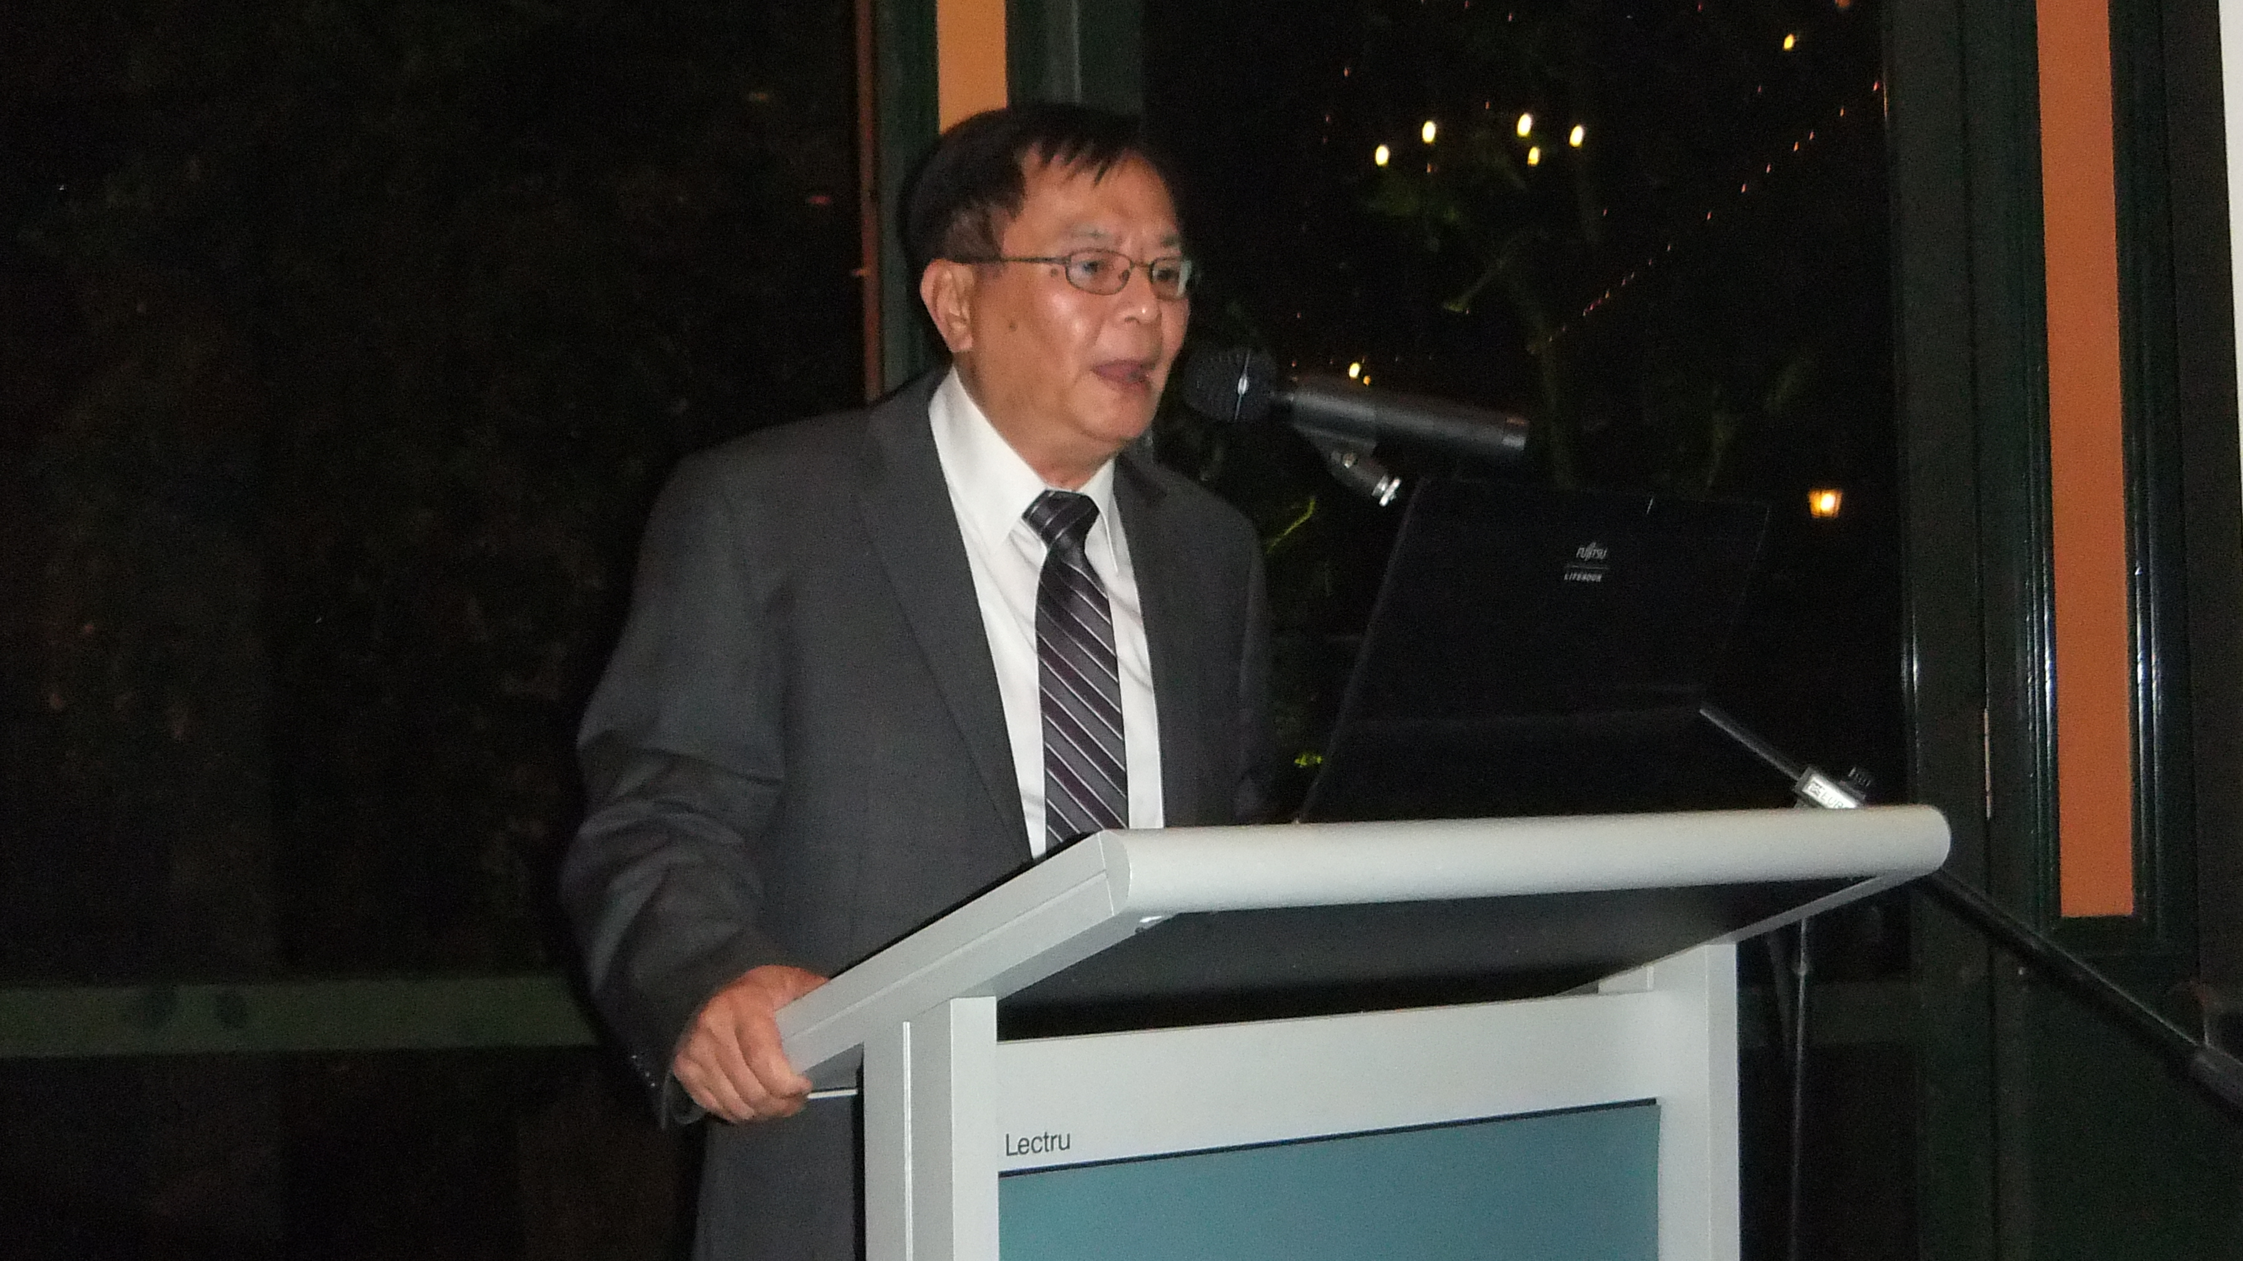
Dr Lan Lam Research Leader of CSIRO Energy Technology Flagship presenting a talk on “CSIRO UltraBattery for Hybrid-electric vehicles and wind-energy applications”

The speaker was introduced by Dr Mark Pszczel vice chair of the section who provided very concise introduction of such eminent speaker Dr Lam has presented a very informative presentation taking listeners on a journey from the principles of a 150 year-old lead acid energy-storage system – into a dynamic technology that will open pathways to low emission transport and renewable energy storage. The presentation considered the need for a new battery cell that combined the advantages of: the supercapacitor and the lead-acid cell. These two technologies combine in UltraBattery to provide the high charge–discharge rates of the supercapacitor and the greater energy storage of the lead–acid cell. The UltraBattery has been comprehensively tested both in Australia and internationally and has been proven to offer a number of advantages over the existing nickel-metal hydride batteries used in hybrid electric vehicles. The Ultra Battery is 70% less expensive than other batteries it offers faster charge and discharge rates and has a comparable performance in terms of fuel consumption carbon-dioxide emissions and cycle life. The speaker has highlighted a number of benefits of the CSIRO UltraBattery such as:
UltraBattery technology is being developed for two major applications: low emission transport, specifically hybrid electric vehicles (HEV), and renewable energy storage from wind and solar sources. The UltraBattery is not intended to replace regular car batteries. Instead, the technology presents an opportunity to be integrated into new, low emission HEV designs.
There are a number of benefits that the UltraBattery could have for renewable energy supply for example, reliability, stability, load levelling, remote area power supply and emergency backup. For renewable energy storage, it is expected that the discharge and charge power will be 50 per cent higher and the cycle-life at least two times longer than that of the conventional lead-acid counterpart currently used for renewable energy storage.
CSIRO has licensed UltraBattery technology for automotive applications to The Furukawa Battery Co Ltd in Japan and East Penn Manufacturing Co Inc in North America. These commercial licenses extend through the regions of Japan, Thailand, North America, Mexico and Canada.
The opportunity was also taken at the dinner to present Prof Bob Bognar with the charter for the newly established Life Members Affinity Group and to present Luke Balzan with the 2011 SA Section Distinguished Young Volunteer Award for notable services and contributions towards the advancement of IEEE and the engineering professions and recognition of significant contribution to the South Australia Section.
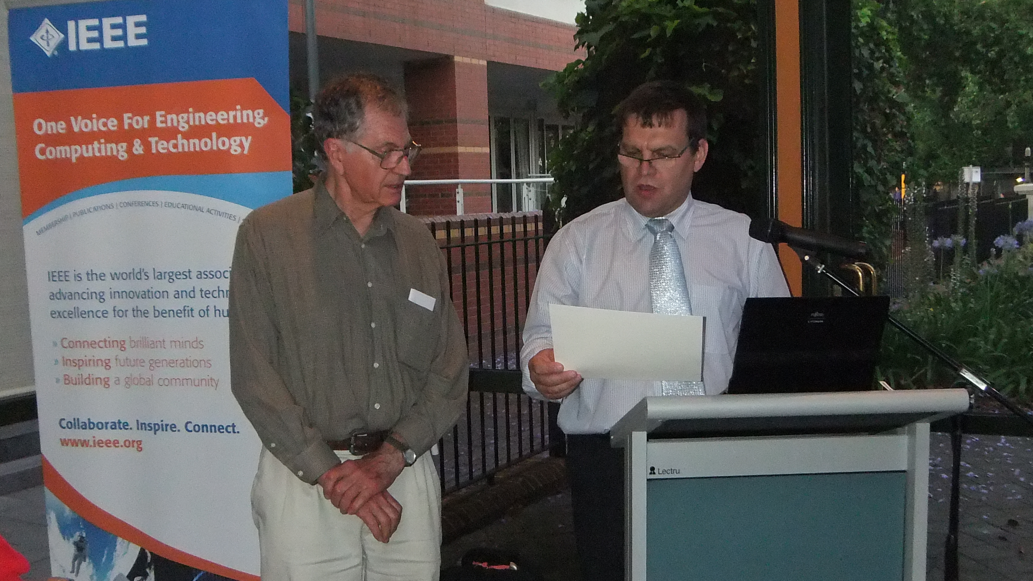
Chair of IEEE SA Section, Dr Andrew Piotrowski, presents the charter for the Life Members Affinity Group to Prof Bob Bognar, Chair of LMAG.

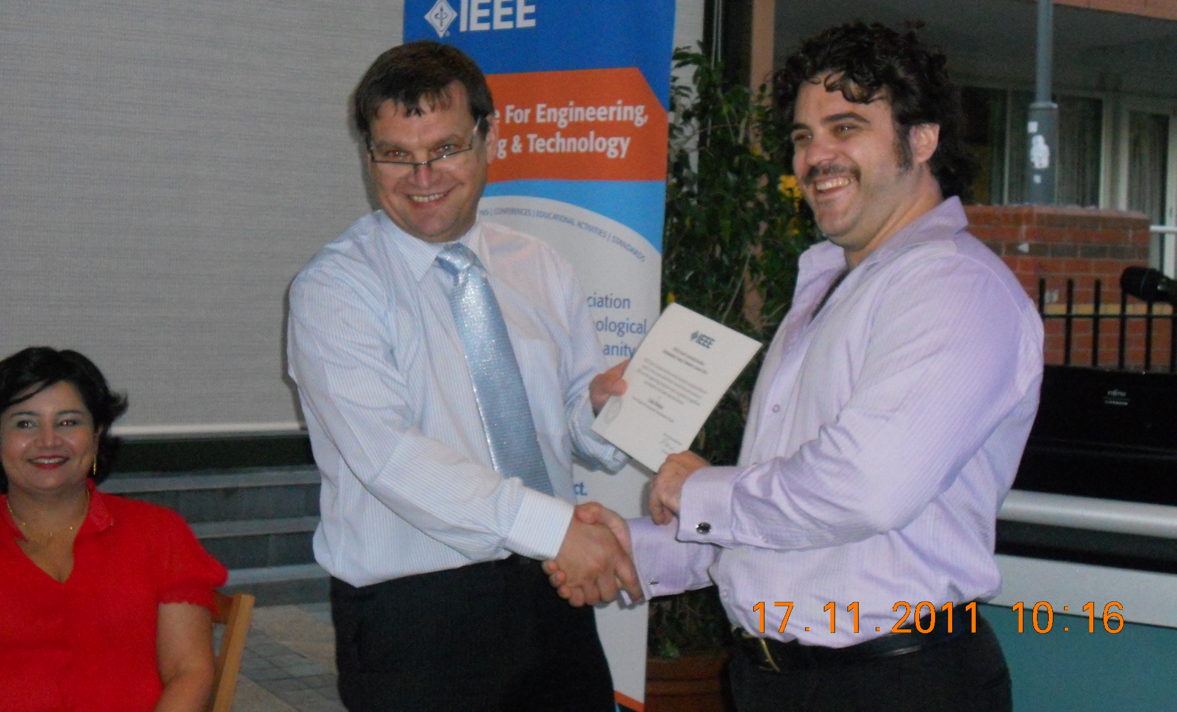
Chair of IEEE SA Section Dr Andrew Piotrowski presents Dr Luke Balzan with the 2011 SA Section Distinguished Young Volunteer award.

The last business of 2011 was the Annual General Meeting (AGM) that was held on 7 December. The AGM was preceded by a talk by Professor Andrew C. W. Zannettino, Head, Myeloma Research Laboratory on “Mesenchymal Stem Cells: Identification and Therapeutic Use”. This talk was designed to open our engineering community to other topics that are not directly related to the field of engineering. Despite my initil doubts about how this topic would be received by members, it turned out to be a huge success, judging by the number of questions after the presentation it was a huge success.
Prof Zannettino talked about Mesenchymal Progenitor Cells (MPC), which are rare stem cells present within post-natal tissues and that possess highly promising therapeutic properties. Commercialization of technology for identification and isolation of these rare cells from bone marrow lead to the formation of the Mesoblast Group, which has a combined capitalization of $2.8 billion. Prof Zannettino has showed the use of MPC cells to develop therapies for spinal fusion, osteoarthritis, congestive heart failure, heart attacks, eye diseases, diabetes, and bone marrow repair. His very informative story showed the journey of the technologies covering the identification and isolation of these rare MPC cells “from bench to bedside”.

C.3 Problems to be anticipated
The Section anticipates the finding young people to be active IEEE volunteers will be one of the challenges that our section is facing in the future. Young member are under huge time pressure from their employees/careers, families and friends. Finding spare time to volunteer in the professional organization often means scarification of personal time.

C.4 Best Practices of your section (which you would like share with other sections for the benefits of members).
I believe that South Australia Section Distinguished Lecturer series is and important event that was presented in the last ten years. The Distinguished Lecture is an important part of South Australia IEEE Section calendar providing not only opportunity for social interactions between members but also expanding their horizon beyond electrical and electronic engineering.

PART D - GOALS AND PLANS
D.1 Continuation of Project/Activity in Progress and Their Implementation Plans
In 2012, we will continue to support student members with travel grant awards to support their attendance at the international and national conference to present their papers.
Newly established Life Members Affinity Group that has already worked under IET Retired Engineers Group had its inaugural AGM and will continue providing excellent support to retired engineers.
In addition, former SA chair, Michael Evans became the SA Section’s first History POC in 2009 and he continues in that role.

D.2 Goals and Future Plans
South Australia section is supporting creation in the near future of the Australian IEEE I&M (Instrumentation and Measurement) Chapter. I believe it is a good timing and an opportunity to consolidate our interest in this field and also to federate the 100+ Australian members of the I&M Society in a Australia wide Technical Chapter. The aim of this Chapter will be to bid to host the I2MTC Conference in Australia that usually attracts 400-500 participants.
Recent interest in formation of Power and Energy Society chapter in our section has attracted a lot of attention with 30 members of this society the chapter have a great chance to successfully submit the petition.

