IEEE Malaysia Section Report (2011)

PART A - SECTION SUMMARY

A.1 Executive Summary

A.1.1 The section executive committee members for year 2011 being elected during the 21st Annual General Meeting on 15th January 2011 and their portfolio are as follow:

 | Portfolio | Member Name
1. | Chair | Mahamod Ismail
2. | Vice-Chair/Membership/Chapter Development | Mustafar Kamal Hamzah
3. | Hon. Secretary | Low Sew Ming
4. | Hon. Treasurer | Maryam Mohd Isa
5. | Professional Activities/Industrial Relation | Zainal Abu Kassim
6. | Communication/Newsletter | Kalai Selvan Subramaniam
7. | Educational Activities | Hafizal Mohamad
8. | Student Activities | Yasmin H Mohd Thayoob
9. | Past Chair/Award and Recognition | Zaiki Awang
10. | Auditor | Zainab Abu Bakar
11. | Auditor | Low Pik Jian

A total of six Executive Committee meetings and two chapter chairs meetings were held during the year of 2011

A.1.2 Section Highlights

A.1.2.1 2011 has been another busy year for IEEE Malaysia. The Section has again successfully carried out a lot of activities ranging from conferences and technical talks to social events. Membership continued to increase indicated a positive development in attracting Electronics and Electrical professionals to join IEEE Malaysia.

The Section this year emphasized on the chapters’ activities. As such a Leadership training camp was organized by the Section early in the year to provide the chapter leadership comprehensive information to run the chapters. A major bulk of the financial resources was spent on supporting chapter events through chapter grants and giving priority to conference activities.
A.1.2.2 A total of 42 conferences were successfully organized in 2011. These are listed below:

- Events with IEEE Organising Unit as Full Sponsor in IEEE Xplore

 | Meeting Title | Organizational Unit | Meeting Date
1 | 2011 IEEE 7th International Colloquium on Signal Processing and Its Applications (CSPA 2011) | CS23 | Mar 2011
2 | 2011 IEEE Symposium on Computers & Informatics (ISCI 2011) | IE13/IA34/PEL35 | Mar 2011
3 | 2011 IEEE Applied Power Electronics Colloquium (IAPEC 2011) | IE13/IA34/PEL35 | Apr 2011
4 | 2011 IEEE Control and System Graduate Research Colloquium | CS23 | Jun 2011
5 | 2011 IEEE International Conference on System Engineering and Technology | CS23 | Jun 2011
6 | 2011 Clean Energy Technology (CET 2011) | IE13/IA34/PEL35 | Jun 2011
7 | 2011 IEEE-EMBS Malaysia-Shenzhen-Hong Kong-Macau Chapter InnoHealth Colloquium | EMB18 | Jul 2011
8 | 2011 International Conference on Space Science and Communication (IconSpace) | VT06/COM19 | Jul 2011
9 | 2011 International Conference on Open Systems (ICOS 2011) | C16 | Sep 2011
10 | 8th IEEE Regional Symposium on Micro and Nanoelectronics (IEEE-RSM2011) | ED15 | Sep 2011
11 | 2011 IEEE Symposium on Business, Engineering & Industrial Applications (ISBEIA 2011) | IE13/IA34/PEL35 | Sep 2011
12 | 2011 IEEE Symposium on Industrial Electronics and Applications (ISIEA 2011) | IE13/IA34/PEL35 | Sep 2011
13 | 2011 IEEE Symposium on Wireless Technology & Applications (ISWTA 2011) | IE13/IA34/PEL35 | Sep 2011
14 | 2011 IEEE Conference on Sustainable Utilization Development in Engineering and Technology (STUDENT 2011) | IE13/IA34/PEL35 | Oct 2011
15 | 2011 IEEE 2nd International Conference on Photonics (ICP 2011) | PHO36 | Oct 2011
16 | 2011 IEEE 17th Asia-Pacific Conference on Communications (APCC) | VT06/COM19 | Oct 2011
17 | 2011 IEEE 10th Malaysia International Conference on Communications (MICC) | VT06/COM19 | Oct 2011
18 | 2011 IEEE Int. Conference on Control System, Computing and Engineering | CS23 | Nov 2011
19 | 2011 IEEE International Conference on Signal and Image Processing Applications (ICSIPA) | SP01 | Nov 2011
20 | 2011 IEEE International RF and Microwave Conference | AP03/MTT17/EMC27 | Dec 2011
21 | 2011 IEEE Conference on Computer Applications & Industrial Electronics (ICCAIE 2011) | IE13/IA34/PEL35 | Dec 2011
22 | 2011 IEEE Colloquium on Humanities, Science & Engineering Research (CHUSER 2011) | IE13/IA34/PEL35 | Dec 2011
23 | 2011 IEEE Student Conference on Research and Development (SCORED 2011) | Malaysia Section | Dec 2011

- Events with IEEE Organising Unit as Technical co-Sponsor in IEEE Xplore

 | Meeting Title | Organizational Unit | Meeting Date
1 | 2011 5th Malaysian Conference in Software Engineering (MySEC) | C16 | Dec 2011
2 | 2011 International Conference on User Science and Engineering (i-USEr 2011) | C16 | Dec 2011
3 | 7th International Conference on IT in Asia | C16 | Jul 2011
4 | 2011 International Conference on Electrical, Control and Computer Engineering (INECCE) | C16 | Jun 2011
5 | 2011 International Conference on Semantic Technology and Information Retrieval (STAIR) | C16 | Jun 2011
6 | 2011 Third Conference on Data Mining and Optimization | C16 | Jun 2011
7 | 2011 International Conference on Pattern Analysis and Intelligent Robotics | C16 | Jun 2011
8 | 2011 International Conference on IT and Multimedia (ICIM) | C16 | Nov 2011
9 | 2011 International Conference on Research and Innovation in Information Systems (ICRIIS) | C16 | Nov 2011
10 | 2011 National Postgraduate Conference (NPC) | C16 | Sep 2011
11 | 2011 Sixth International Conference on Bio-Inspired Computing: Theories and Applications (BIC-TA) | C16 | Sep 2011
12 | 2011 4th International Conference on Mechatronics (ICOM) | C16 | May 2011
13 | 2011 3rd International Congress on Engineering Education (ICEED 2011) | E25/WIE | Dec 2011
14 | 2011 International Conference on Electronic Devices, Systems & Applications (ICEDSA 2011) | IE13/IA34/PEL35 | Apr 2011
15 | 2011 International Symposium on Humanities, Science & Engineering Research (SHUSER 2011) | IE13/IA34/PEL35 | Jun 2011
16 | 2011 International Conference on Business, Engineering and Industrial Applications (ICBEIA 2011) | IE13/IA34/PEL35 | Jun 2011
17 | International Symposium & Exhibition In Sustainable Energy & Environment (ISESEE) | PE31 | Jun 2011
18 | 5th Int. Power Engineering and Optimisation Conference(PEOCO2011) | PE31 | Jun 2011
19 | 2011 Fourth International Conference on Modeling, Simulation and Applied Optimization (ICMSAO) | RA24 | Apr 2011

A.1.2.3 Mahamod Ismail and Norman Mariun attended the Section Congress /R10 AGM meeting 2011 at San Francisco from 19th – 22nd August 2011.
Mahamod Ismail and Mustafar Kamal Hamzah attended the Region 10 meeting on 5th – 7th March at Yogyakarta, Indonesia.

PART B - ORGANIZATIONAL ACTIVITIES
B.1 Membership Development Activities
B.1.1: The total number of members according to membership status as of December 2011 is presented below.

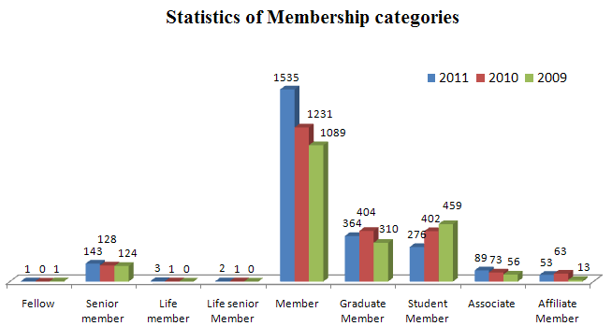

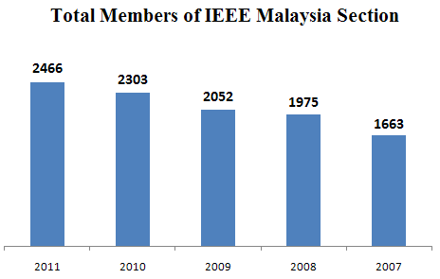
The above figures indicate the number of members in all categories (except Affiliate, Graduate and Student Member) has increased from 2010. Accordingly, the total number of IEEE Malaysia members in 2010 increased by about 7% compared to 2010.

B.1.3: The number of members according to the technical societies in 2011 compared to the last three years are as follows:-
Society | 2008 | 2009 | 2010 | 2011
AES010 Aerospace and Electronic Systems | 22 | 31 | 22 | 11
AP003 Antennas and Propagation | 64 | 90 | 88 | 53
BT002 Broadcast Technology | 15 | 28 | 14 | 5
C016 Computer | 329 | 466 | 426 | 262
CAS004 Circuits and Systems | 89 | 118 | 139 | 75
CE008 Consumer Electronics | 37 | 48 | 40 | 13
CIS011 Computational Intelligence | 35 | 48 | 78 | 53
COM019 Communications | 587 | 866 | 760 | 388
CPMT021Components, Packaging and Manufacturing | 49 | 63 | 50 | 44
CS023 Control Systems | 58 | 89 | 85 | 66
DEI032 Dielectric and Electrical Insulation | 17 | 22 | 25 | 20
E025 Education | 43 | 42 | 70 | 43
ED015 Electron Devices | 89 | 121 | 108 | 88
EM014 Engineering Management | 43 | 64 | 41 | 0
EMB018 Engineering in Medicine and Biology | 47 | 38 | 67 | 56
EMC027 Electromagnetic Compatibility | 34 | 41 | 37 | 21
GRS029 Geoscience and Remote Sensing | 14 | 22 | 25 | 21
IA034 Industry Applications | 46 | 58 | 65 | 35
IE013 Industrial Electronics | 55 | 60 | 80 | 46
IM009 Instrumentation and Measurement | 58 | 51 | 65 | 27
IT012 Information Theory | 24 | 34 | 22 | 6
ITS038 Intelligent Transportation | 6 | 9 | 9 | 3
MAG033 Magnetic Society | 11 | 15 | 16 | 14
MTT017 Microwave Theory and Techniques | 94 | 114 | 100 | 65
NNS011 Neural Networks Society | 1 | - | - | -
NPS005 Nuclear Plasma Science | 5 | 5 | 6 | -
OE022 Oceanic Engineering | 7 | 8 | 20 | 19
PC026 Professional Communication | 13 | 16 | 11 | 5
PE031 Power Engineering | 130 | 168 | 159 | 141
PEL035 Power Electronics | 47 | 41 | 68 | 67
PHO036 Photonics Society (formerly IEEE LEOS) | 53 | 75 | 73 | 50
PSE043 Product Safety Engineering | 1 | 2 | 3 | 3
RA024 Robotics and Automation | 66 | 67 | 95 | 79
RL007 Reliability | 19 | 29 | 21 | 13
SIT030 Social Implications of Technology | 21 | 22 | 24 | 9
SMC028 Systems, Man and Cybernetics | 30 | 35 | 55 | 42
SP001 Signal Processing | 91 | 120 | 129 | 86
SSC37 Solid-State Circuits | 37 | 62 | 44 | 29
UFF020 Ultrasonics, Ferroelectric | 8 | 10 | 7 | 5
VT006 Vehicular Technology | 30 | 30 | 44 | 19
WIE050 Women in Engineering | 125 | 266 | 192 | 141

B.1.4: Social Meetings and Membership Drives were carried out at various institutions in order to attract more professionals and students to join IEEE and enjoying the benefits of a member. The following list the membership drive conducted during the year 2011.
1 | AP03/MTT17/EMC27 | Jan 2011
2 | PE31 | Feb 2011
3 | IE13/IA34/PEL35 | Mar 2011
4 | C16 | Apr 2011
5 | GOLD | May 2011
6 | PHO36 | May 2011
7 | IE13/IA34/PEL35 | Jun 2011
8 | CPMT21 | Sep 2011
9 | CPMT21 | Sep 2011
10 | PHO36 | Oct 2011
11 | PHO36 | Oct 2011
12 | RAS | Oct 2011
13 | IE13/IA34/PEL35 | Oct 2011
14 | SP001 | Oct 2011
15 | SP001 | Nov 2011
16 | SP001 | Nov 2011
17 | EMBS | Dec 2011
18 | EMBS | Dec 2011
19 | IE13/IA34/PEL35 | Dec 2011

B.2 Chapter Activities
B.2.1: There are four joint chapters, fourteen chapters, and two affinity groups under IEEE Malaysia Section. The technical chapter and affinity group chairs are as shown in Appendix.
B.2.2: No new chapter was formed in 2011. Submission of Computational Intelligent chapter (CIS011) has been supported by the Section, pending approval from HQ.
B.2.3: Most of the chapters were actives and the less active chapters have been supervised by Membership /Chapter Development portfolio.
B.2.4: Chapter Activities
The activities for chapters were summarized as follow:
 | Adm. meeting | Conferences /Symposium | Technical-talk /seminar /Workshop | Non-technical
AP03/MTT17/EMC27 | 9 | 1 | 31
CAS04 | 4
C16 COMPUTER | 8 | 13 | 10 | 1
ComSoc/VT | 5 | 3
Consumer Electronics | 4 |  | 2
CPMT21 | 12 |  | 2 | 2
CSS23 | 21 | 4 | 9 | 1
E25 Education | 5 | 1 | 7
EMB18 | 13 | 1 | 21 | 3
PEL35/IE13/IA34 | 31 | 12 | 19 | 68
PE31 | 2 | 2 | 4
SP | 14 | 1 | 16 | 5
MTT-S/EDS/SSCS Penang | 1 |  | 9
ED15 | 13 | 1 | 22 | 3
IM09 | 1 |  | 3
RAS | 1 | 1 | 11 | 2
SMC28 | 3 |  | 2
PHO36 | 13 | 1 | 14 | 8
GOLD | 2 |  |  | 4
WIE | 1 | 1 | 2 | 2
- The figures above are based on the L31 reported statistics as of 3:30pm 28th December 2011.

B.3 Professional and Continuing Education Activities
B.3.1 Professional Activities /Industrial Relation
Freescale Cup 2011 which was organized by the Professional Portfolio in conjunction with PECIPTA 2011 held at the Kuala Lumpur Convention Centre from September 13th – 15th, 2011. UiTM was the sponsor of this event; Freescale Malaysia and PELS chapter were the co-sponsor with CS chapter as the technical co-sponsor. This event recorded an overwhelming success with a total of 40 teams (compared to last year’s 24 teams in Freescale Smart Car Competition) of more than 120 electrical and electronics engineering undergraduates from 19 local public and private universities participated in the competition. 30 teams were from IEEE SB.

Winners for Freescale Cup Competition:
1st Place – UTM KL (Team: Inno Team)
2nd Place – Swinburne University of Technology (Team: Swinburne 2)
3rd Place – Swinburne University of Technology (Team: Swinburne 1)
Best Technical Report Award – Monash University (Team: Innotech)
Best Design Award – UTM KL (Team: Inno Team)

B.3.2 Educational Activities
B.3.2.1 Leadership Training Camp was organized by Section on the 2nd April 2011 at Mines Wellness Hotel, Seri Kembangan. As there were quite a number of new chapter chairs, this camp aimed to provide comprehensive information and sharing of experience on the running of the chapters and the guidelines on organizing IEEE conferences. The speakers were Norman Mariun, Mahamod Ismail, Zaiki Awang, Low Sew Ming, Maryam Isa, and Mustafar Kamal Hamzah.
B.3.2.2 11 delegates from some chapters (PELS:5, CS:2, SP:1, EduSoc:1, R10 PES:2) attended IEEE POCO 2011 held in Beijing to update current policies and best practices in organizing IEEE conference.

B.4 Students Activities
B.4.1: There are 14 student branches under the Section. The list of IEEE Student Branches and updated IEEE Student Branch Counselors and Chairs from the IEEE online system for all the Universities under the IEEE Malaysia Section as of 15 December 2011, are listed below.
No | Name of IEEE Student Branches | Chair | Counselor
1 | University of Malaya | Roziana Ramli | Fatimah Ibrahim
2 | Universiti Sains Malaysia | Mohd Akmal Mohd Yusoff | Mohd Rizal Arshad
3 | Universiti Tunku Abdul Rahman | Chia Loon Cheng/  Khai Shan Lee | Ezra Morris A Gnanamuthu
4 | Universiti Tenaga Nasional | Aiman Ismail | Yasmin H Md Thayoob
5 | Universiti Kebangsaan Malaysia | Position Vacant | Position Vacant
6 | Mara University Of Technology-Shah Alam | Nazmi Abd Ghani | Anees Abdul Aziz
7 | Universiti Putra Malaysia | Mohamad Azwan Abdul Aziz | Mohd Nizar B Hamidon
8 | Universiti Teknologi Petronas | Position Vacant | Position Vacant
9 | Intl Islamic Univ Malaysia | Ahmad Hafiz Yahaya | Hany E Abdel-Raouf
10 | Universiti Malaysia Sabah | Cheah Meng Ong | Farrah Wong
11 | Multimedia University | Umair Ashfaq Bhatti | Mohamad Y Alias
12 | Monash Univ Sunway Campus | Yi Xiong Chong | Veera Ragavan S.
13 | Curtin Univ of Tech – Sarawak Campus | Yin Ling Leong | Waseem Ahmed
14 | Universiti Teknologi Malaysia | Siti Nurhidayah Naqiah Abdull | Mazlina Esa

B.4.2: There was no new student branch formed in 2011. UTHM has shown interest to form a student branch in the university.

B.4.3: Student Activities
B.4.3.1 On 19th-20th December 2011, the IEEE MMU Student Branch team, with the help of organizing committee members from Multimedia University, successfully organized the IEEE SCOReD 2011, held at Kelab Komuniti Taman Tasik Cyberjaya. There were about 100 registered papers coming from 15 countries.
B.4.3.2 PELS chapter co-sponsored the Junior Inventor in PECIPTA 2011 involving 24 secondary school competing 38 products.

B-4-4: Student Branch Activities
B.4.4.1 During this period, the reported activities from the SB were as follows.

 | Adm. meeting | Technical | Non-technical | Others |  | Total membership
UPM SB | 19 | 6 | 2 | 1 |  | 69
UMS SB | 36 | 3 | 2 |  |  | 24
UTM SB | 5 | 5 | 9 | 10 |  | 69
Uniten SB | 4 | 6 | 8 | 2 |  | 35
For details of each item, please refer to the SB annual report in the respective SB meeting.

B.4.4.2 MMU SB participated in the EXTREME 2011 competition and also organized SCOReD 2011.

B.5 Affinity Group Activities
B.5.1 Graduate of the Last Decade (GOLD)
The current GOLD membership stood at 528.

B.5.2 Women in Engineering (WIE)
IEEE Malaysia WIE has co-organised several technical and educational activities throughout 2011. In addition, the affinity group was one of the technical co-sponsors for 3rd International Conference on Engineering Education (ICEED 2011). This year, Region 10 has provided travel allowance for the chair of WIE Malaysia to attend the Region 10 Student/GOLD/WIE Congress in Auckland, New Zealand. The congress was a good platform for women in engineering to explore new and existing ideas, network and discuss issues in their profession.

B.6 Awards & Recognition Activities
B.6.1 Award constituted by the section
Outstanding Volunteer Award and Best Chapter Award were presented during the annual dinner to be held on the 7th January at Marriot hotel, Putrajaya.

B.7 Communication Activities (Newsletter, Home Page, E-mail etc.)
B.7.1 Newsletter
Communication /Newsletter Portfolio created IEEE Malaysia section Facebook Page http://www.facebook.com/IEEE.my to accelerate the communication between members. As of Dec 2011, the number of members: 23
B.7.2 Home Page
Communication and Newsletter portfolio in the process of migrating to new domain at http://www.ieeemy.org.
The Chapters, Student Branches and Affinity Groups may be reached via the addresses as shown in the Appendix.
B.7.3 Other means of contact
The section also communicated via the following mailing-list / googlegroups to specified members.
ieee-mychairs@googlegroups.com
ieeemyxcom@googlegroups.com
ieeemy@googlegroups.com

Prepared by Approved by

Low Sew Ming Mahamod Ismail
Hon Secretary Chair
IEEE Malaysia Section 2011 IEEE Malaysia Section 2011

SCOReD2011

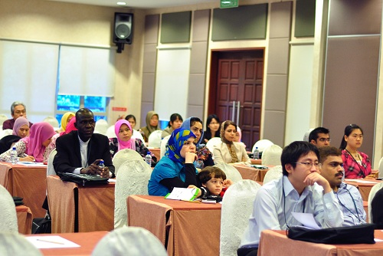
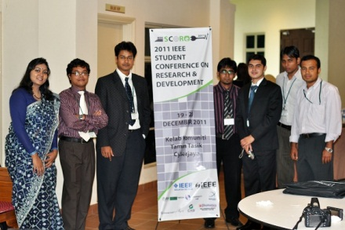

Freescale Cup 2011
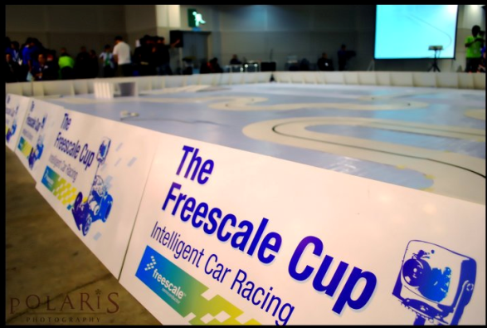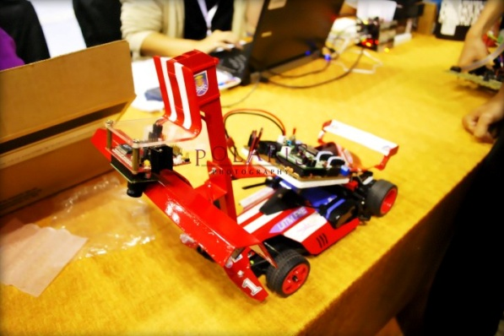

Conferences (ICSIPA2011)


