PART A - IEEE GWANGJU SECTION SUMMARY

A.1 Executive Summary

In year 2011, the Section offered a number of technical and social meetings. Most activities were given at the campus of GIST, Korea. Speakers were invited not only from all over Korea but also from abroad. For example, Dr. Ho-Jin Song who is a renowned engineer at NTT Corporation, Japan, gave a talk in a single day workshop on Microwave Photonics organized by Prof. Jongin Song, GIST, Korea, the Chair of IEEE Gwangju Section, given to IEEE members, Oct. 24th, 2011. His talk was on Terahertz Technologies for Sensing, Imaging, and Communications. Another interesting event includes a single day Special Session on Compressed Sensing, which was organized, and held on Sept. 24th, 2011, by Prof. Heung-No Lee, the Secretary of IEEE Gwangju Section. Several professors who are renowned for their work on Compressed Sensing were invited and gave a talk in this special session. Speakers from all over Korea came and gave a talk. Attendees were excited about the new possibilities made by the new theory of Compressed Sensing. The meeting was continued to heated discussion by several professors during the dinner and after hour bar time, following the session. It was a big success. It showcased that Compressed Sensing, which is a new signal acquisition and sampling paradigm, is gaining a lot of attention recently in Korea.
In year 2011, IEEE Gwangju Section maintained about 200 members including 59 student members. In year 2012, we plan to offer more technical workshops and social meetings. We will leverage on the IEEE Distinguished Speakers programs, and plan to invite world renowned IEEE scholars to give talks to our students and local section members. We are aiming to increase the number of student members in 2011. For this, we are making plans to encourage a senior group of GIST students to organize an IEEE student section. As one of our effort under this direction, Prof. Kiseon Kim, our former IEEE Section Chair and currently a section executive, will make a trip to 2012 IEEE Region 10 Executive Committee Meet, 3rd and 4th, March 2012, in Kolkata, India.

- Section Executive Committee Member List
CHAIR | Jongin Song | jisong@kjist.ac.kr
SECRETARY/TREASURER | Heung-No Lee | heungno@gist.ac.kr
VICE CHAIR | Mike Myung-Ok Lee | mikelee@hichips.com
MEMBERSHIP DEVELOPMENT | Dong Soo Har | hardon@gist.ac.kr
MEMBER-AT-LARGE | Kiseon Kim | kskim@kjist.ac.kr
MEMBER-AT-LARGE | Dae Jin Kim | djinkim@chonnam.chonnam.ac.kr
MEMBER-AT-LARGE | Kwang Man Lee | kwangml@cheju.cheju.ac.kr
MEMBER-AT-LARGE | Seong Jun Kang | sjkang@chungkye.mokpo.ac.kr
MEMBER-AT-LARGE | Yo-Sung Ho | hoyo@kjist.ac.kr
PROFESSIONAL ACTIVITIES | Chong Keun Jwa | keunjc@cheju.cheju.ac.kr
EDUCATIONAL ACTIVITIES | BYUNGLOK CHO | blcho@sunchon.sunchon.ac.kr
SPECIAL ACTIVITIES | Myoung Shin Kwak | mskwak@gist.ac.kr

A.2 Financial Report

The Section had two sources of income in 2011, one is the IEEE HQ Rebate in the amount of 3,086,854KRW and the other is the interest income of 1,398KRW. We spent all the income on IEEE technical meetings and social events in 2011. Please refer to the following file for a detailed financial report.

- Summary (as per submitted L50) - 2011-GEO.UNIT.L50.STD FORM Nov 22, 2011

PART B - ORGANIZATIONAL ACTIVITIES

B.1 Membership Development Activities

In year 2011, two membership development talks were given:

- Prof. Kiseon Kim, GIST, Korea gave a talk on IEEE organization, with the title of Past and Future of IEEE Gwangju Section, on 18st Aug 2011.
- Prof. Heung-No Lee (Secretary of IEEE Gwangju Section) gave a talk on Section’s plan on Distinguished Lecture Programs of IEEE in 2011/2012, on Sept. 24th, 2011.

B.3 Professional and Continuing Education Activities

There were three professional technical meetings held in 2011.

- 18st Aug 2011, Origin of the Korean Seminar

This was an all day workshop. The number of attendees was about 16, including five professors and students. Engineers sometimes limit their views within a limited scope, and it is an interesting idea to invite an open topic beyond the scope of pure science and engineering:

Speaker1: Prof Sugil Ann (Seoul National Univ, Korea)
Speaker2: Prof. Kiseon Kim (GIST, Korea)

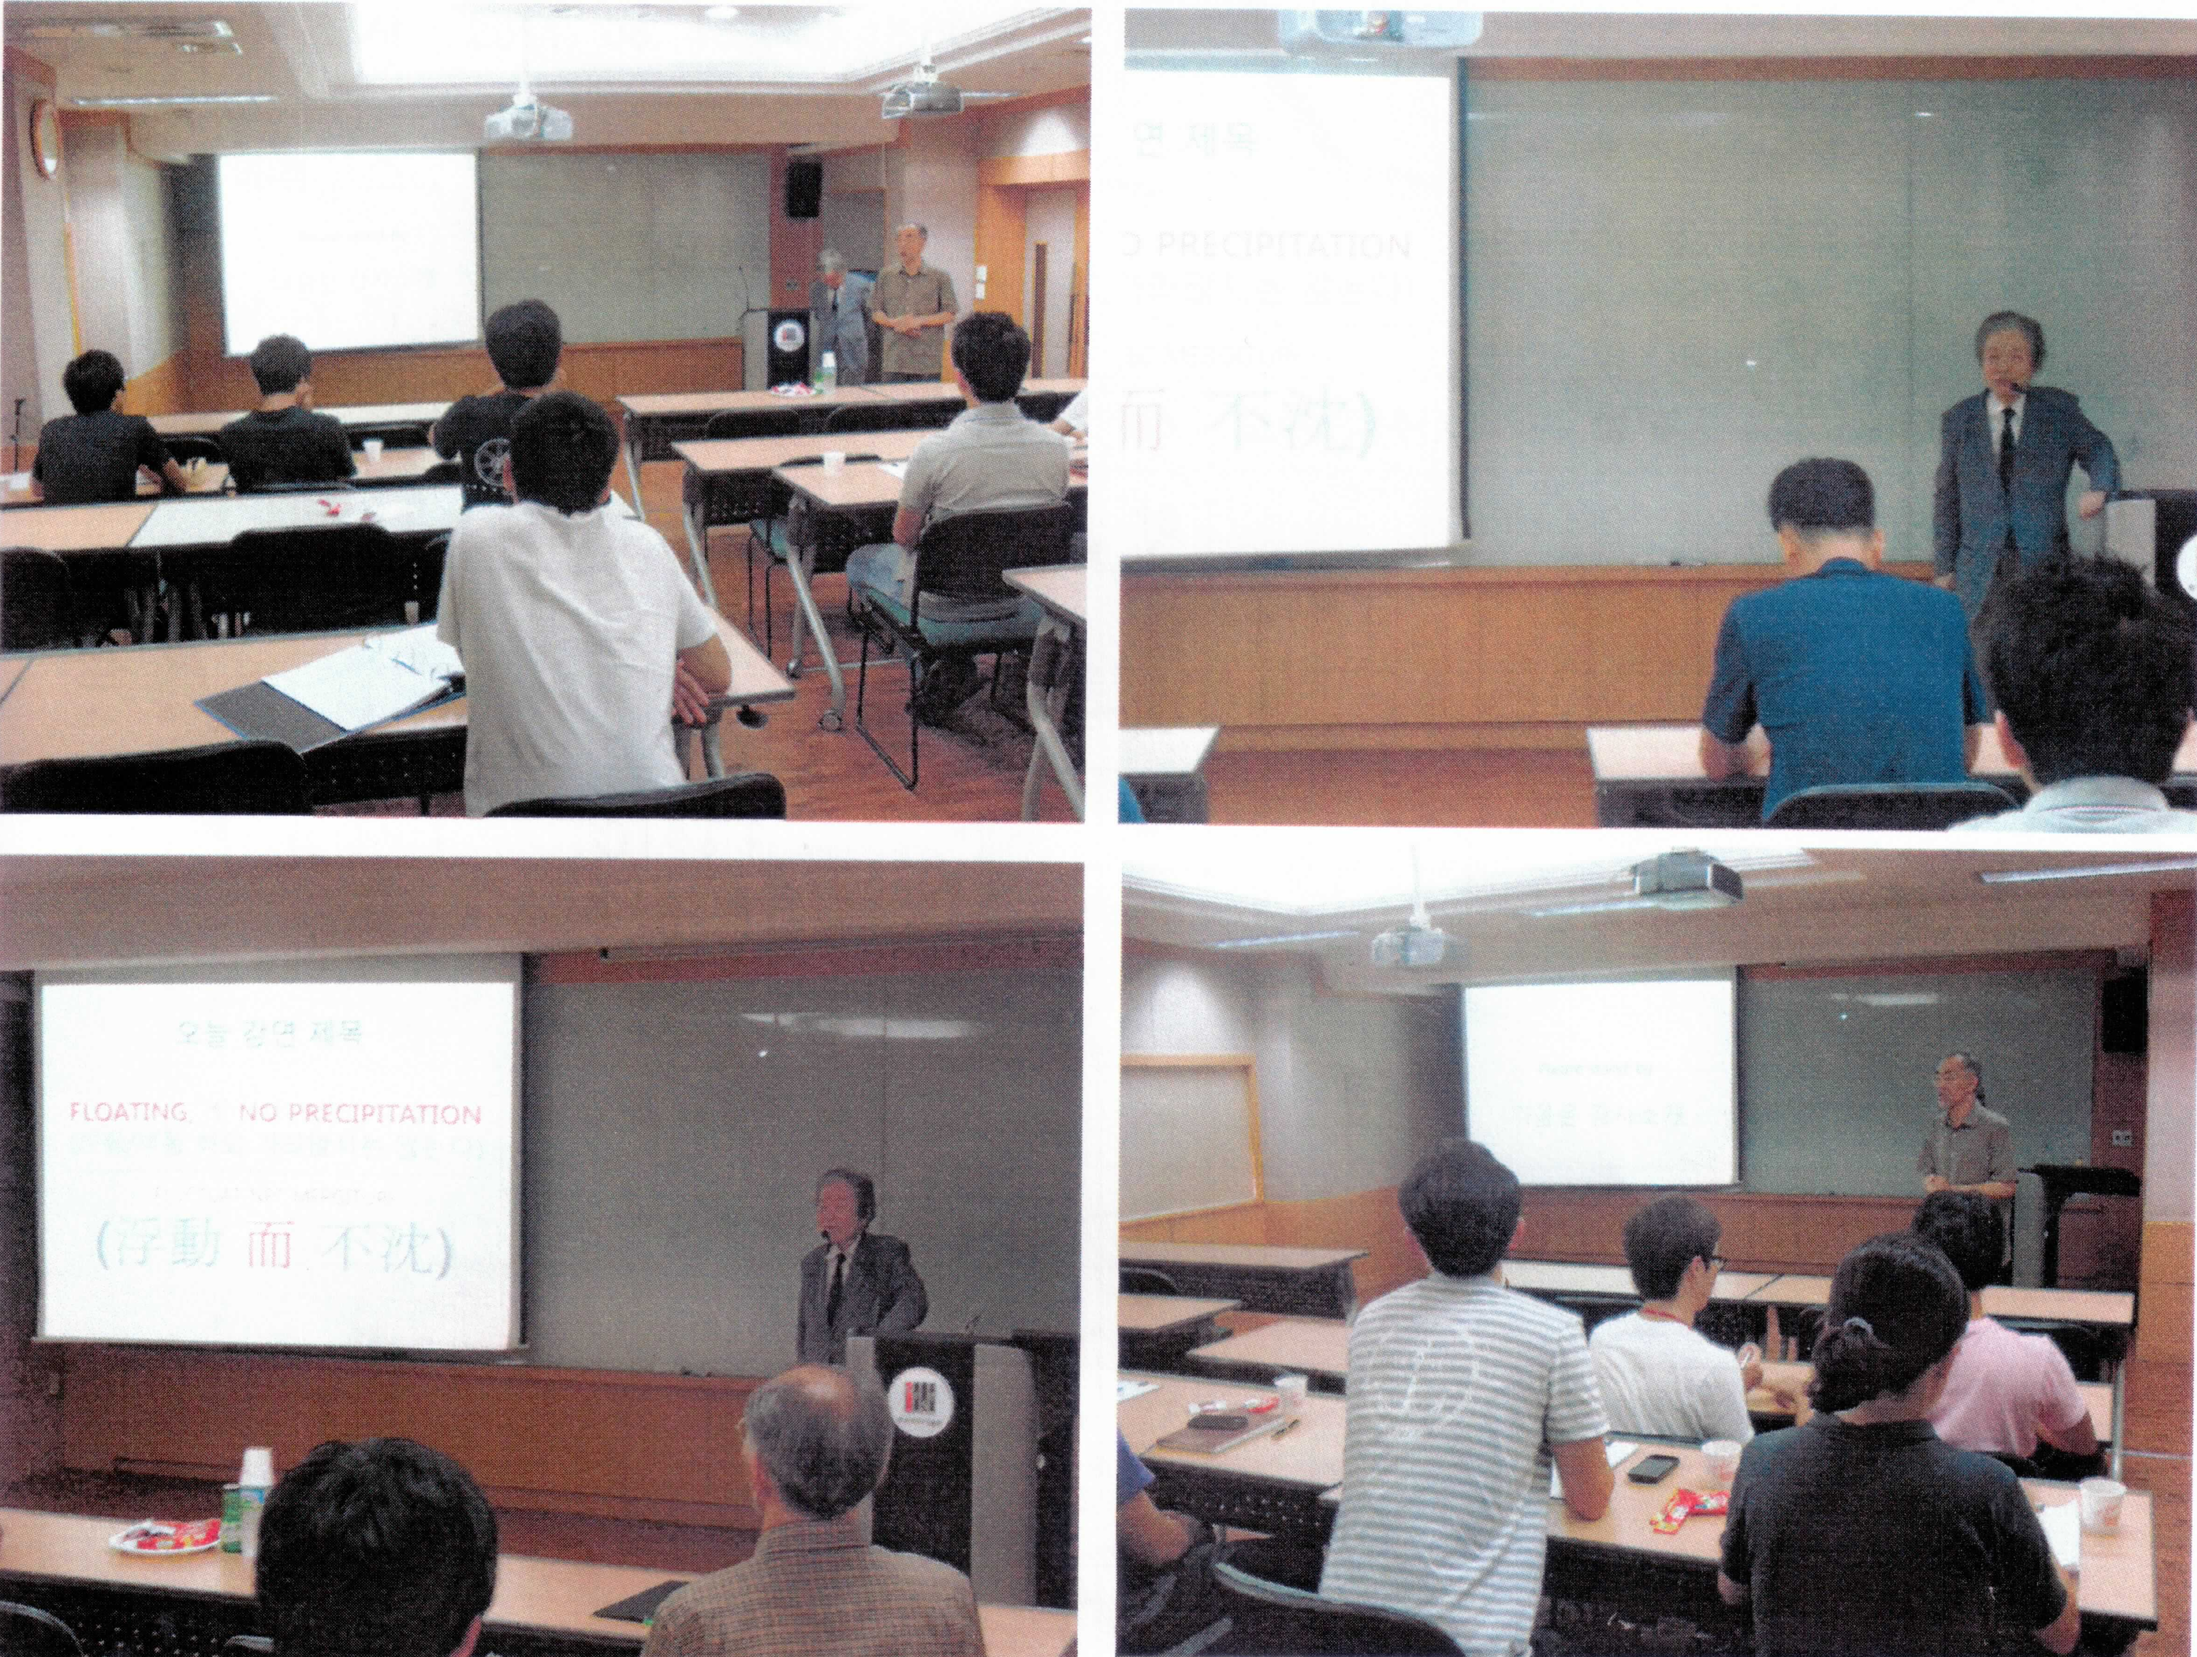

- 24st Sep 2011, Korean Signal Processing Conference

Prof. Heung-No Lee, the Secretary of IEEE Gwangju Section, organized a special session on Compressed Sensing. This was an all day workshop. The number of attendees was about 50, including professors, their students, and other professionals from all over Korea. There were six invited speakers, listed as follows:

Speaker1: Prof. Jong Chul Ye (KAIST, Korea)
Speaker2: Prof. Kilhyun Kwon (KAIST, Korea)
Speaker3: Prof. Byeonghyo Shim (Korea University, Korea)
Speaker4: Prof. Jeong A Lee (Chosun University, Korea)
Speaker5: Prof. Bang Chul Jeong (Yong Nam University, Korea)
Speaker6: Prof. Kiseon Kim (GIST, Korea)
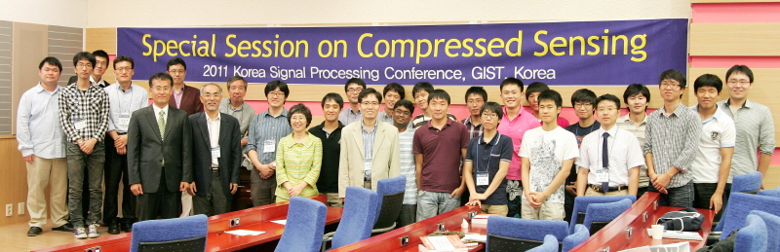

- Oct. 24th, 2011, Microwave photonics Workshop

This was an all day workshop. The number of attendees was about 32, including professors and students. Dr. Song from NTT Corporation, Japan, was invited who gave a talk on recent research in Terahertz technologies worldwide.

Speaker1: Prof. Jong-In Song (GIST, Korea)
Speaker2: Dr. Ho-Jin Song (NTT Corporation, Japan)
Topic: Discussion of Terahertz Technologies for Sensing, Imaging and Communications.

B.4 Students Activities

There are no items to be reported in this section.

PART C - OTHERS

There are no items to be reported in this section.

PART D - GOALS AND PLANS

In year 2012, the section aims to invite IEEE Distinguished Lecturers from IEEE Signal Processing, Information Theory, and Communications Societies. The list of speakers we are interested in contacting have been compiled and they are given as follows:

IEEE Signal Processing Society Distinguished Lecturer Programs
- Adali Tulay (UMBC, USA), Joint Blind Source Separation: Applications in Medical Image Analysis
- Eldar, Yonina C. (Tel-Aviv University (TAU), Tel-Aviv, Israel), Compressed Sensing: The Next Generation

