South Australia Section
CHAIR’S REPORT

A1. Executive summary

Firstly, I would like to thank all the Excom committee members that have supported me this year: Mark Pszczel- vice chair, Ian Clark / Michael Evans – treasurer and Karl Sammut/ Sherry Randahawa - secretary.

I would like to thank also nonexecutive members of the committee supporting me such as: chairs of chapters with their Excom members:
- AP/MTT Christophe Fumeaux
- CAES Cheng Chew Lim
- C&SP Luke Balzan
- Computer Sebastien Wong
- IT Terrence Chan
- GOLD Anthony Milton
- WIE Pina Dall’Armi-Stoks
- LMAG Bob Bognar
- Conference support coordinator Leigh Powis
- Web master Bobby Yau
- Retired Engineers Liaison/Section History Michael Evans
- Student Activity coordinator Brian Ng
- Industry Liaison Ian Clark
- and distinguished lecture dinner organizing committee: Mark Pszczel, Leigh Powis and Pina Dall’Armi-Stoks

Let me also congratulate Michael Evans on receiving R10 Distinguished service award. His award is very well deserved. Michael has been the Section chairs, who has established Distinguished Lecture Dinner and hold numerous positions at number of IEEE SA section sponsored conferences. Well done Michael.

For Our section, the year 2012 was a year full of activities and growth. In support our members and the local community IEEE SA Section and chapters had organized 41 technical and professional activities during 2012, 15 administrative meetings out of which 7 were Section meetings.

AP/MTT | CAES | Computer | C&SP | IT | GOLD | WIE | LMAG | Section JTP | Section
7(1) | 5(1) | 2 (2) | 1(1) | 2 | 2(1) | 2 (1) | 6 (1) | 12 | 2 (7)
Our Section membership is 561 members strong and out of it

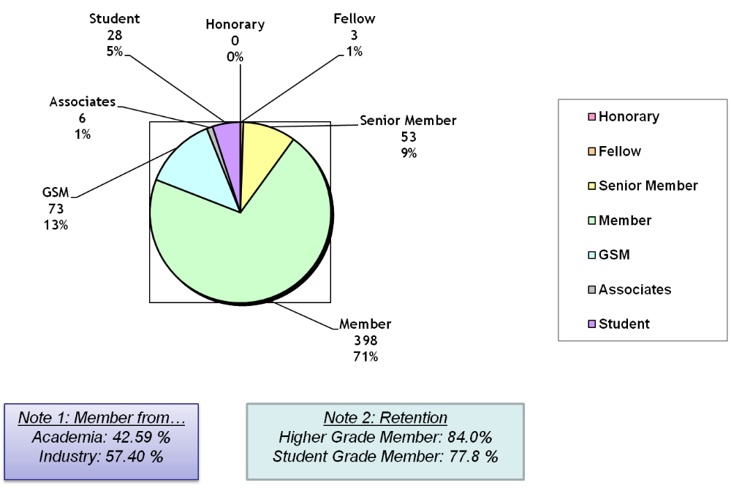

The IEEE SA Section Committee met six times in 2012 (7 Feb, 17 Apr, 19 Jun, 14 Aug, 15 Oct, including the AGM on 22 Nov). In addition to the full committee meetings, the Section Officers held additional meetings as required to discuss matters arising between the scheduled dates of the full Committee meetings. The Section Committee members also maintained ongoing contact by email to deal with issues that could be handled by electronic means.
Continuing its long-standing programs of support to students in SA, the IEEE SA Section awarded three grants in 2012 to research students in support of their travel to present papers at international conferences.

- Shifu Zhao et al, Optimized helical monopole antennas for portable VHF communication devices”, IEEE international symposium on antennas and propagation (AP-S), July 8-14, 2012 in USA.
- Ali Karami Horestani, et al. Miniaturized Bandpass Filter with Wide Stop-band Using Complementary Spiral Resonator, 2012 Asia-Pacific Microwave Conference December 4-7, 2012

- Zahra Shaterian et al, Impact of Different Node Distributions on the Meshless Radial Point Interpolation Method in Time-Domain Electromagnetic Simulations, 2012 Asia-Pacific Microwave Conference December 4-7, 2012

Three IEEE SA Section Awards for Excellence in Engineering were presented to students of the three South Australian universities:

Mr Nghia Nguyen Trong from University of Adelaide
Ms Cathryn Ellen McDonald from University of Adelaide
Both Second Year Students in the Bachelor of Engineering degree, for the best overall performance in all Level II subjects.

Mr Benjamin Turner from University of South Australia, the Second Year Student in the Bachelor of Engineering and associated double degrees, who most distinguishes themselves in the course Signals and Systems.

Mr Rowan Q. Pivetta, from Flinders University, the Second Year Student in the Bachelor of Engineering and associated double degrees, who most distinguishes themselves in the overall engineering component of the second year topics achieving a GPA of 6.62.

These awards were presented at the JTP Student Papers Night on 23 October 2012.

As part of the IEEE SA Section participation in the Joint Technical Program (JTP) Electrical, the IEEE SA Section hosted 3 of the 12 JTP technical meetings.

A2 Financial Report
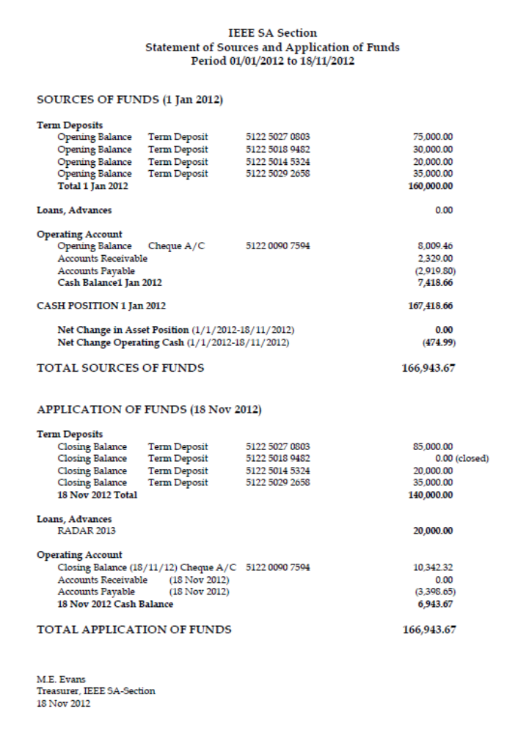

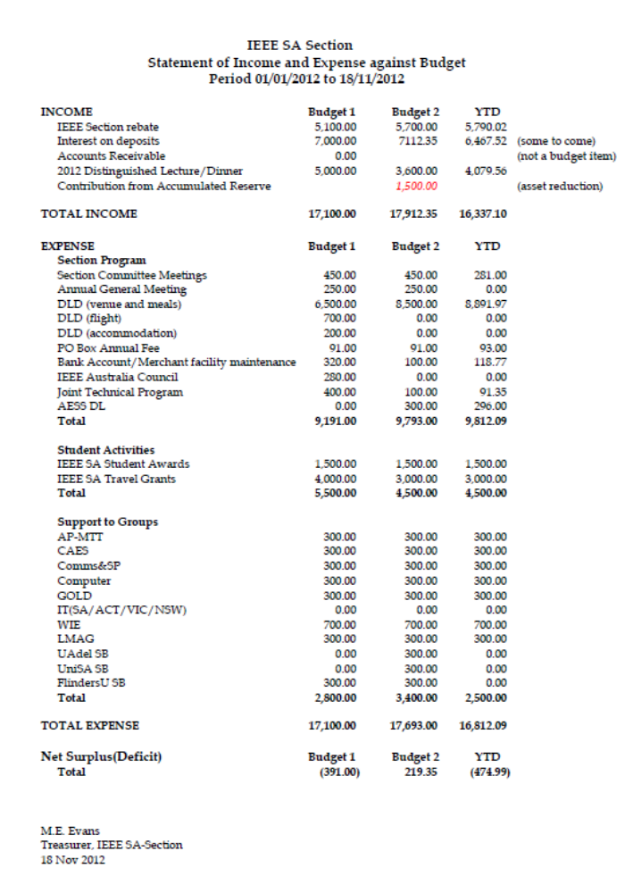

B.1 Membership Development Activities
The SA section has now three IEEE Fellows: Prof Derek Abbott, Prof Don Sinnott, and Prof Michael Gibbard.

Prof Karl Samnut continued as the SA Section’s Membership Development coordinator during 2012. He has established a network of suitable contacts and referees in the Section to assist members who wish to upgrade their membership.

Andrew Piotrowski has presented membership development talk “IEEE global and local perspectives – is the membership worth your money” on 7 September 2012 at JEWSOU. This talk was well attended with 24 military technical staff attending it and asking questions about the IEEE and the local section.

B.2 Chapter Activities
IEEE South Australia section has five active chapters: Computer, Communication/Signal Processing, Antenna Propagation/Microwave Theory & Technique, Control/Aerospace and Electronic Systems, Information Theory (SA/ACT/VIC). In addition the Australia Council has Australia wide Instrumentation & Measurements Society (IMS) chapter.

Technical activates of each chapter are shown in their AGM reports.

B.3 Professional and Continuing Education Activities
The IEEE SA Section has provided seed money for the RADAR2013. The Section is financial co-sponsor with Engineers Australia and technical co-sponsor with AESS Society and IET SA and NT branch.

Radar 2013 - Beyond Orthodoxy: New Paradigms in Radar
Adelaide 9 to 12 September 2013
The 2013 International Conference on Radar Systems will be held in Adelaide, Australia, from 9 to 12 September 2013. The conference will be hosted at the Hotel Grand Chancellor Adelaide on Hindley.

This conference represents a unique opportunity for participants in the radar industry from Australia and overseas to exchange knowledge and ideas on both the theories and practices that will drive radar technology, education and research in the coming years.
Much of the progress in radar science, technology and applications follows a path of evolutionary development as component technologies, signal processing algorithms, materials science and computational electromagnetics provide ever more efficient means of implementing the radar systems on which our modern societies depend, and improving their performance against established criteria. This evolutionary process pays immediate and predictable dividends to manufacturers and users alike. Yet, every so often, we encounter a revolutionary development in some supporting technology, or a novel idea which springs from the imagination of just one or two individuals, which changes the way we think about radar and how this form of sensing can be exploited. Such developments are infrequent but important, not only for the capabilities they provide but for the way they inspire lateral thinking and innovation.
Radar 2013 welcomes contributions in all areas of radar science and engineering, but particularly encourages papers which open new avenues for exploration and force us to embrace new paradigms.

The conference website is at: http://www.aomevents.com/Radar2013
The conference is co-sponsored by the IEEE SA Section and by Engineers Australia

B.4 Students Activities
IEEE South Australia has three student branches at Adelaide University, University of South Australia and Flinders University. Continuing its long-standing programs of support to students in SA, the IEEE SA Section awarded three grants in 2012 to research students in support of their travel to present their papers at international conferences.
1991, the IEEE South Australia Section established a Travel Fund to support students to attend national and international events relevant to IEEE activities. The scheme continues to attract strong interest. This year, the following students received travel awards:
- Shifu Zhao et al, Optimized helical monopole antennas for portable VHF communication devices”, IEEE international symposium on antennas and propagation (AP-S), July 8-14, 2012 in USA.
- Ali Karami Horestani, et al. Miniaturized Bandpass Filter with Wide Stop-band Using Complementary Spiral Resonator, 2012 Asia-Pacific Microwave Conference December 4-7, 2012

- Zahra Shaterian et al, Impact of Different Node Distributions on the Meshless Radial Point Interpolation Method in Time-Domain Electromagnetic Simulations, 2012 Asia-Pacific Microwave Conference December 4-7, 2012.

In addition to this travel grants, IEEE SA Section presents awards for Excellence in Engineering to engineering students of the three South Australian universities, the awards are presented at the JTP Student Papers Night.
The student Subject prize-winners for the IEEE South Australia Section 2011 Student Award for Excellence in Engineering with an electrical and/or electronics emphasis were presented to:
Mr Nghia Nguyen Trong from University of Adelaide
Ms Cathryn Ellen McDonald from University of Adelaide
Mr Benjamin Turner from University of South Australia
Mr Rowan Q. Pivetta, from Flinders University,

The Student Branches at The University of Adelaide and the University of South Australia continued their high levels of activity with University of Adelaide student branch chair Simon Knight and UniSA student branch chair Volkan Dedeoglu / Rajan Kadel. The Flinders University Student Branch has been reactivated during 2012, with Damien Tohl as student branch chair. Brian Ng was the Student Activities Coordinator of the SA Section in 2012.

B.5 Affinity Group Activities
South Australia Section has three Affinity Groups: Graduates Of the Last Decade (GOLD), Women In Engineering (WIE) and Life Members Affinity Group (LMAG).

The reports for GOLD and WIE are included in their AGM reports.

LMAG:
LMAG had recently it AGM and the new officers for LMAG are:
Chair Prof Harry Green for 2 years since Nov 2011
V-chair Prof Keith Kikkert for 2 years since Nov 2012
LMAG in 2012 had the following meetings:
15 Feb AGM and “New Blips on the Radar Screen, Radar Research”
Prof Doug Gray, Dir U of A Radar Research Centre, Prof of Elec Eng U of A
11 Apr “Lasers in Ophthalmology”
Dr Stewart Lake, specialist, Dept of Ophthalmology, Flinders Med Centre.
(Joint Meeting EA REG/IET REG )
6 Jun “Where from/How old? (Fluoro luminescence dating)” (Partners Lunch)
Ms Frances Williams, President of the Field Geology Club.
29 Aug “Optimising Wind Power Production Economics”
Robert Dickenson, Director, Hydricity SA, a division of Dataspace Insight P/L.
10 Oct “Microalgal Biofuels: The Beauty and the Beast”
Assoc Prof Peter Ashman, School of Chemical Engineering, Univ. of Adelaide.
14 Nov “T-ray Imaging and Sensing (Terahertz radiation)” Prof Derek Abbott, the School of Electrical
Electronic Engineering, Univ. of Adelaide.

B.6 Awards & Recognition Activities
Continuing its long-standing programs of support to students in SA, the IEEE SA Section awarded three grants in 2012 to research students in support of their travel to present their papers at international conferences.

In addition to this travel, three IEEE SA Section Awards for Excellence in Engineering were presented to students of the three South Australian universities, the awards being presented at the JTP Student Papers Night.

Congratulations to the newly established IEEE South Australia Life Members Affinity Group for being included on the 2012 list of Outstanding Life Members Affinity Groups.

A successful year of IEEE SA Section activities was celebrated with the Annual Distinguished Lecture and Dinner at Adelaide Convention Centre on 8 October 2012. The event was attended by over 80 members, professional colleagues and guests.

B.7 Communication Activities (Newsletter, Home Page, E-mail etc.)
The IEEE SA Section has abandoned the tradition of issuing paper form of Section Newsletters in 2008. Instead, it is using information on its website (ewh.ieee.org/r10/s_australia) and Section E-Notices to keep members informed of events. Seven E-notices were issued this year.

Bobby Yau served as the SA Section webmaster and has updated our web site 6 times a year, whereas Andrew Piotrowski was e-notice editor and provided members with regular updates on the section activities.

B.8 Community Activities

On April 2012 three Day FPGA Workshop: Implementing Image Processing Algorithms on FPGAs. This workshop was presented by Associate Professor Donald Bailey from Massey University. The workshop was very well attended with 16 attendees who each had their own workstation and FPGA board, which was for the students to keep.

B.9 Other Organizational Activities

PART C – OTHERS
C.1 Relationship with National Societies
The IEEE-SA Section has also a very strong collaboration with our professional colleagues in Engineers Australia, the Institution of Engineering and Technology (IET), and the Telecommunication Society of Australia (TSA) through the Joint Technical Program (JTP) and IET Retired Engineers Group. As part of the IEEE SA Section participation in the Joint Technical Program (JTP) Electrical, the IEEE SA Section hosted 3 of the 12 JTP technical meetings and presentations.
The JTP covered topics ranging from 3 site visits to:
- Zero Carbon Australia Stationary Energy Plan
- VISIT to Biomechanical Materials Testing Laboratory at Flinders University – Hexapod Robot
- VISIT to Renewable Energy Centre at Regency campus TAFE
- VISIT to RAAF Edinburgh AP-3C Orion Flight Simulator
- The Integration of Complex Engineered Systems in the ADF Technical Regulatory Environment
- Electrification and upgrade of the Northern Line – DPTI
- Role of the ACMA
- Radar, where did it come from?
- Nuclear Power: From Opponent to Proponent. The essential role of nuclear power for decarbonising a warming world,
- VISIT Electra Net's Newly Commissioned 275/66kV City West Substation,
- National Broadband Network – Update

The JTP also covers STUDENT PAPERS NIGH, during which students from our three universities presented their final year projects whilst competed for the IET Rex Jones Student Presentation Prize. In addition, the IEEE Student Subject prizes were presented at this meeting.

C.2 Special Events
2012 IEEE SA Section Distinguished Lecturer
The 2012 IEEE SA Section Distinguished Lecturer was presented by Laureate Professor Rob Evans from Melbourne University. The lecture on “Consumer RADAR –a new frontier” was delivered at the IEEE SA Section Annual Dinner held at Adelaide Convention Centre on 8 October 2012.
Over 90 guests attended the dinner, including distinguished guests from other professional organisations such as President of Association of Old Crows Mr Jeff Walsh, Engineers Technology Institute SA & NT Branch Chair Mr Simon Calleja, and Chair of SA Division Information Telecommunication and Electronic Engineering Mr Marcelo Botelho.

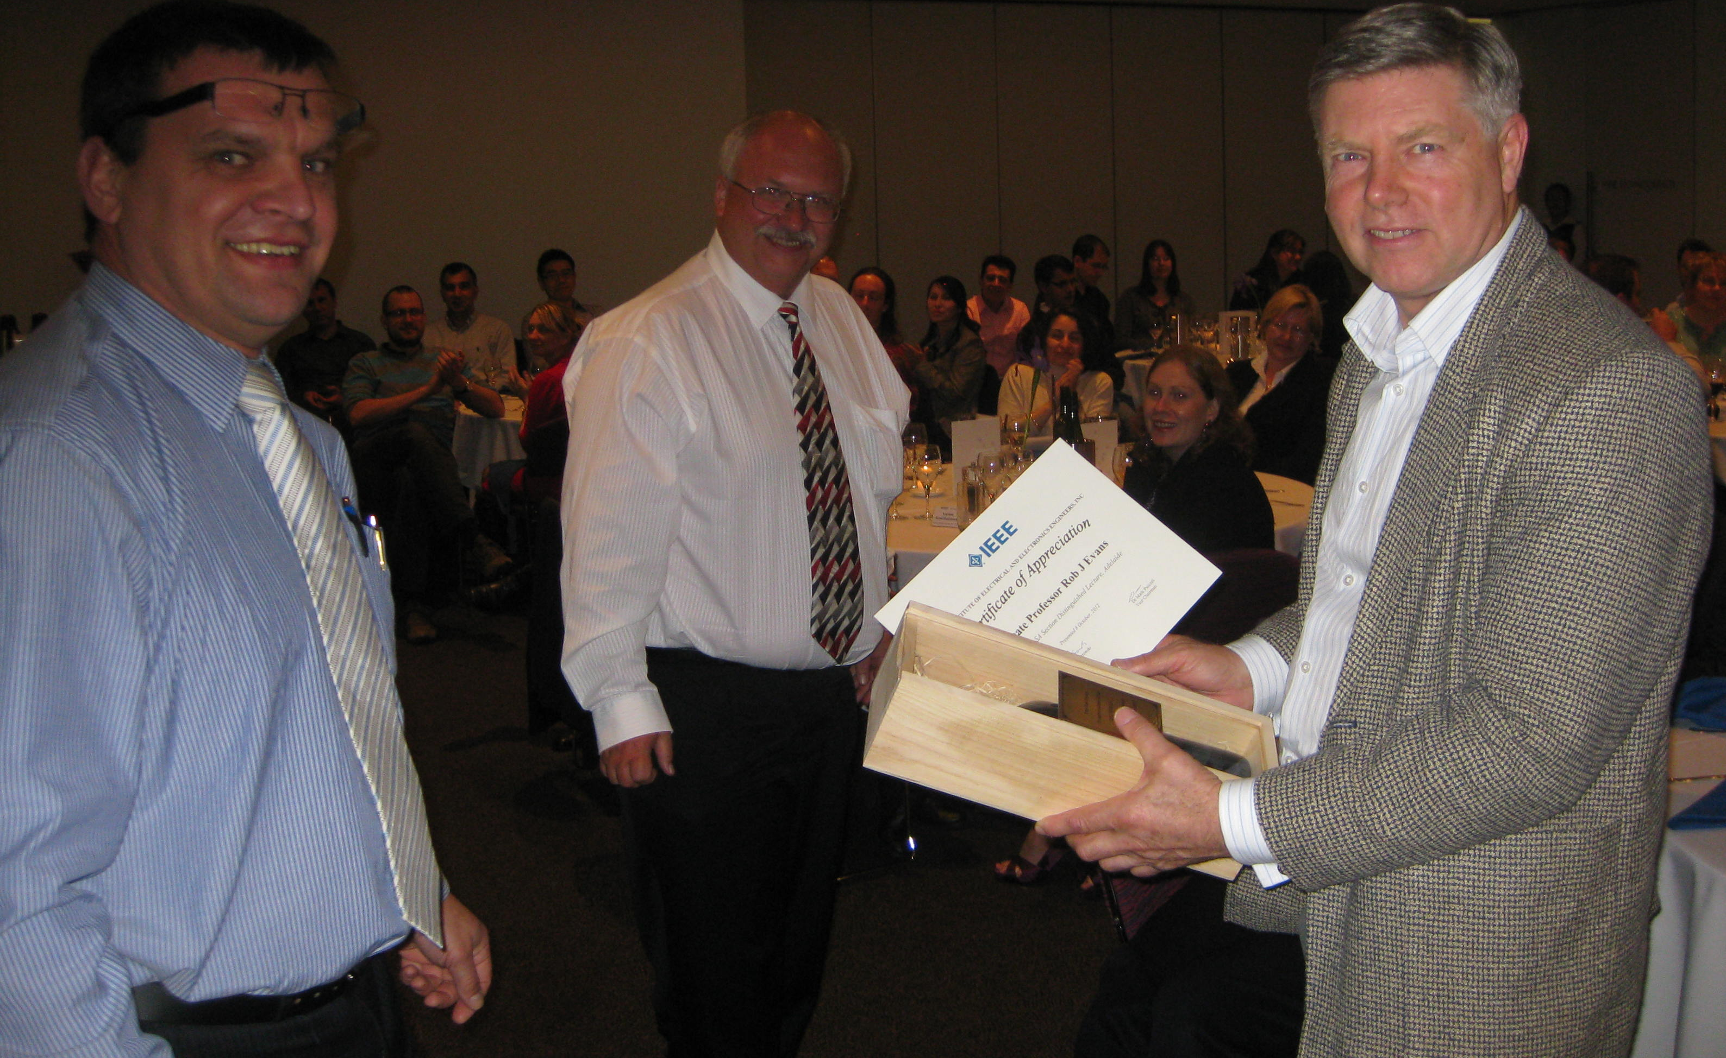
Laureate Professor Rob Evans (right) from Melbourne University presented with the gift after the talk by SA section chair Andrew Piotrowski (left) and vice chair Mark Pszczel (centre)

The members and guests enjoyed great company, a wonderful meal, and the great talk by Professor Rob Evans. Prof Evans presentation was very informative and took listeners on the journey from the early beginning of theory of electromagnetic, the Maxwell’s equations to early RADAR and into the future applications of RADAR.
The presentation started with the history of the electromagnetic research and history of radar from the II world war. This was followed by the current applications of RADAR in vehicles that are opening the possibility of other application of single chip radar. Prof Evans has pointed out that the recent advances in micro-electronics technology have opened-up the possibility of building very low cost and very small single chip RADAR systems. This single chip RADAR when combined with sophisticated waveforms, signal processing and adaptive antenna technology is achieving surprisingly good performance. He has presented examples of some RADAR chips developed by his group at Melbourne University and results achieved with bandwidth of few GHz, 40dB dynamic range and a few Watts power consumption. These chips are measuring just a few cubic centimetres and costing a few tens of dollars. These new RADAR systems hold the key to a whole host of new applications in areas such as transport, UAV’s, security and many others yet unknown application such as RADAR torch. His presentation was nicely sparkled with the images of painting of old masters, which themes have provided the audience with a great way of illustrating message of the slide.
Dr Pina Dall'Armi-Stoks and Dr Sherry Randhawa from WIE Affinity Group were masters of ceremony and have provided a concise and enjoyable introduction to the program with an excellent choice of music in the background.
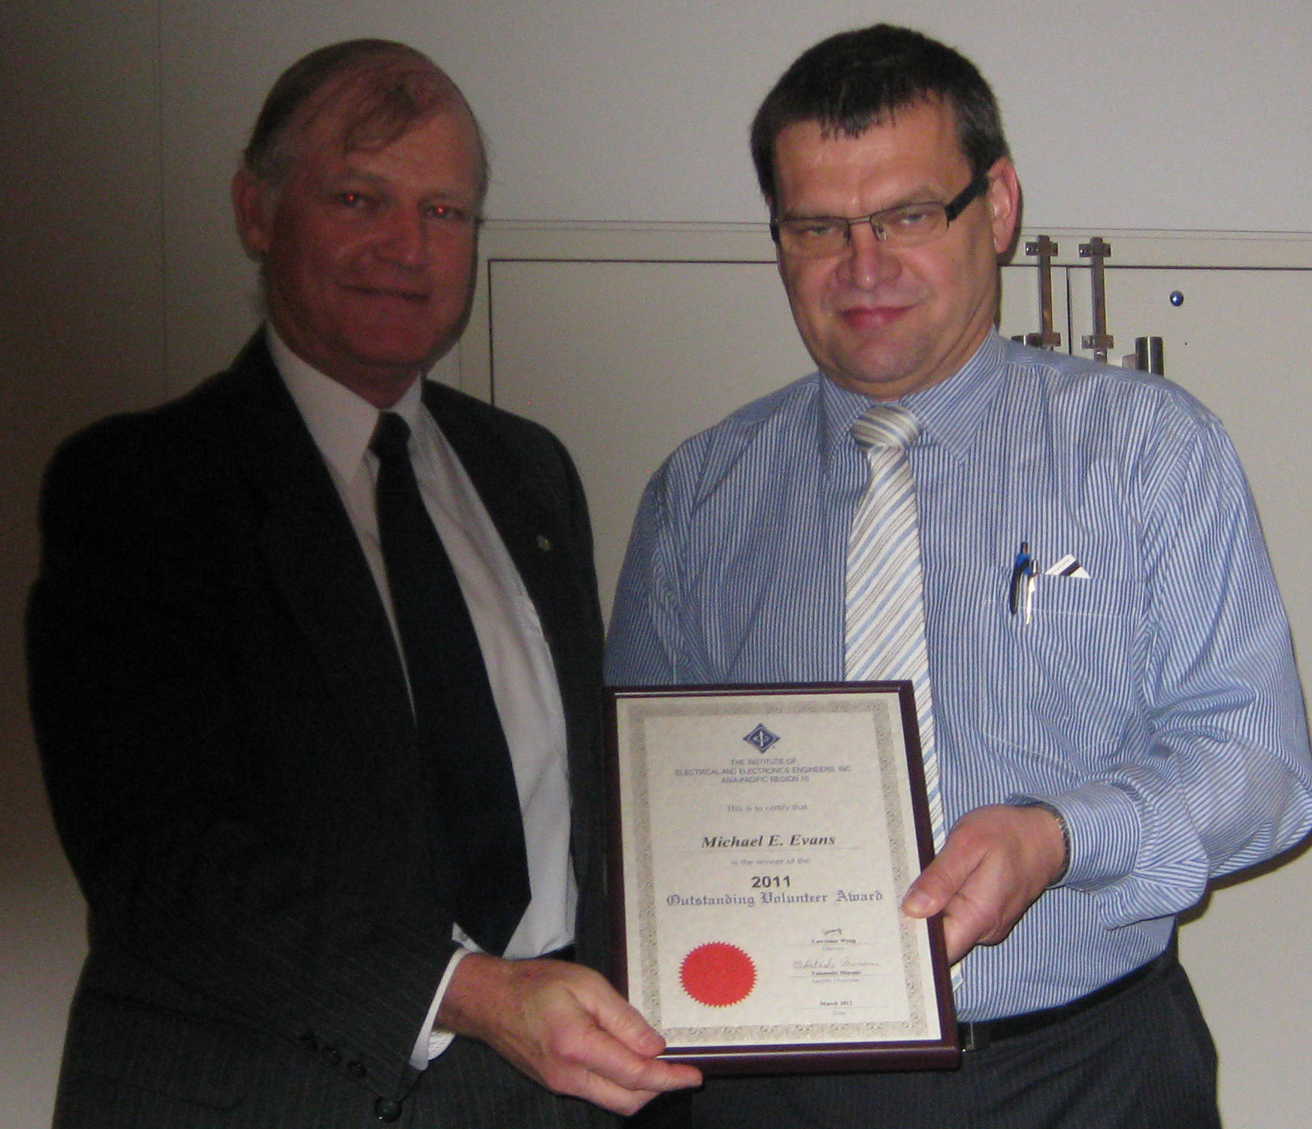
Dr Michael Evans presented with R10 distinguished volunteer award by SA section chair Andrew Piotrowski

The opportunity was also taken at the dinner to present to Dr Michael Evans with R10 distinguished volunteer awards for notable services and contributions towards the advancement of IEEE and the engineering professions and recognition of significant contribution to the South Australia Section.

C.3 Problems to be anticipated
The Section anticipates that finding young people to be active IEEE volunteers will be one of the biggest challenges that our section is facing in the future. Young member are under huge time pressure from their employees/careers, families and friends and finding time for IEEE volunteering is a challenge.

C.4 Best Practices of your section (which you would like share with other sections for the benefits of members).
I believe that South Australia Section Distinguished Lecturer series is an important part of South Australia IEEE Section calendar providing not only opportunity for social interactions between members but also expanding their horizon beyond electrical and electronic engineering.

PART D - GOALS AND PLANS
D.1 Continuation of Project/Activity in Progress and Their Implementation Plans
In 2013, we will continue to support student members with travel grant awards to support their attendance at the international and national conference to present their papers.

D.2 Goals and Future Plans
The SA members of Oceanic Engineering Society are participating in the working group to establish SA/WA & Northern Australia wide Oceanic Engineering Society Chapter.
Dr Mohammet Haque is running the petition to form Power and Energy Society chapter in our section. He has already attracted a lot of support from the membership and with 30 members of this society in the section the PES chapter will be established next year.

Andrew Piotrowski
Chair of IEEE South Australia Section
Andrew.Piotrowski@ieee.org
Ph 08 73896635
Fax 08 73895254

