**Western Australia Section Report 2017**

**PART A - SECTION SUMMARY**

**A.1 Executive Summary – (**Please follow the format given below)

## Section Executive Committee Member List

Chair: Cesar Ortega-Sanchez

Vice-Chair: Ferdous Sohel

Secretary: Vijay Kumar

Treasurer: Sebastian Zander

Member: Adam Osseiran

Member: Anthony Jeganathan

Member: Clive Maynard

Member: Douglas Chai

Member: Du Huynh

Member: GM Shafiullah

Member: Kevin Wong

Member: Valerie Maxville

## Section Highlights

Attended R10 Meeting in Tokyo, Japan. 4-5 March

Sponsored student prizes at the 3 of the 4 WA universities

Attended R10 Sections Meeting in Sydney. August

Supported students to attend Student Congress in Sydney

Technical support to APCC2017. December 2017 in Perth

Had one social activity with families

Had one social dinner

Had 6 Section meetings in the year

Participation in Australian Council

## Major Events (International, National)

Hosted Australia Pacific Communication Conference 2017 in December

## Major Chapter Activities

Chapters organized 20 Technical events in 2017

## Major Student and Affinity Group Activities

Student Branches and Affinity groups organized 21 activities in 2017

## Awards

The Section sponsored 3 awards to the best Electrical Engineering students at 3 WA universities (Curtin, Murdoch and Edith Cowan).

Outstanding Power Engineer Award Presentation to SM Muyeen

**A.2 Financial Report**







**PART B - ORGANIZATIONAL ACTIVITIES**

**B.1 Membership Development Activities**

## Total number of active members in the past 3 years:

2016= 710

2017= 685

## Summary and evidence of work done to improve the value of membership, which leads to retention and growth of members

See list of activities in page 1.

**B.2 Chapter Activities**

* Total number of Chapters in the Section: 8
* Number of Chapters formed in the current year: 1
* Number of active Chapters: 4
* Summary of Chapter activities
  + COM19= 4 technical activities
  + ED15/SSC37/PHO36= 4 technical activities
  + PE31/PEL35= 8 technical activities
  + SMC28= 3 technical activities
  + SP01= 1 technical activitiy

**B.3 Professional and Continuing Education Activities**

Young Professionals and Student Branches organized soldering workshops, mock interview sessions and site visits for students from all 4 public universities in the state.

**B.4 Students Activities**

* Total number of Student Branches in the Section: 4
* Number of Student Branches formed in the current year: 1
* Section level student activities: Interview Preparation Workshop
* Number of active Student Branches: 1
* Summary of Student Branch activities:
  + HMAS Sydney and Kormoran Shipwreck 3D Visualization
  + Interview Preparation Workshop
  + Photo Competition
  + Woodside: Vision 2020+ The Future of Energy
  + Young Professionals Sundowner

**B.5 Affinity Group Activities**

* Young Professional (YP)
  + C Programming Workshop 14th Sep
  + C Programming Workshop 21st Sep
  + C Programming Workshop 7th Sep
  + IEEExtreme 11.0 for Western Australia Team
  + April Sundowner
  + Committee Meeting 04/09/2017
  + Committee Meeting 08/02/2017
  + Committee Meeting 22/06/2017
  + IEEE WA Young Professionals AGM
  + Interview Preparation Workshop & Networking
  + Joint IEEE & IET Sundowner
* Women In Engineering (WIE)
  + BEST POSTER PAPER PRESENTATION AWARDS
  + EECON - BEST POSTER PAPER PRESENTATION AWARDS
  + The WA University Poster Competition

**B.6 Awards & Recognition Activities**

* Award constituted by the Section: 3 awards to the best Electrical Engineering students in 3 public universities.
* Please list all Awards and Recognitions received by the Section, and members in the Section, from R 10 and IEEE HQ during the year 2017: none

**B.7 Communication Activities (Newsletter, Home Page, E-mail etc.)**

* Newsletter- None
* Home Page of the Section: <http://ewh.ieee.org/r10/w_australia/> Updated monthly.
* Other means of contacts with Section members including social media- Email, Collabratec

**B.8 Industry Relations**

* Membership growth and retention
* Activities for/with industrial members

**B.9 Humanitarian Technology Activities**

* Humanitarian Technology related activities supported by the Section including collaboration with other OUs.
* SIGHT Activities

**B.10 Community Activities**

* IEEE Social activities (Family day, IEEE day, Engineers Week)
  + Social dinner at Greek restaurant
  + Dinner with R10 Director
  + Family Day out to celebrate IEEE Day
  + End of the year dinner after AGM

**PART C - OTHERS**

**C.1 Special Events**

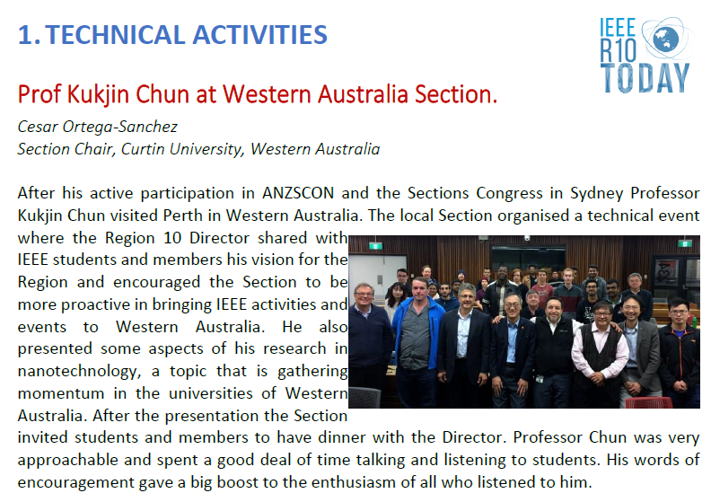

**C.2 Relationship with National and International Societies and Non-Government Organizations (NGO)**

* Nature of relationship and details of any formal agreement signed
* Details of joint activities
* Benefit to IEEE members (for example discounts, access to technical information etc.)
* Benefit to Section (for example help in membership development, venue facilities, cost saving etc.)

**C3. Collaboration with other IEEE Sections**

* Support extended to neighboring Sections
* Joint activities with any other Section

**C.4 Support extended to Sub-sections & Society Chapters within the Section**

* Support extended for organising technical, educational and professional activities
* Joint activities for membership development
* Support extended for the formation of a Sub-section or transition of a Sub-section into a full Section

**C.5 Best Practices of your Section (which you would like to share with other Sections for the benefits of members)**

* Maintain good communication between Section Committee members.
* Support student and Young Professionals activities.
* Play to your strengths. WA members are mainly from academia.

**C.6 Problems anticipated and suggestions for solutions, if any**

* We are finding difficult to recruit new committee members.
* Rotation in student branches makes it difficult to give continuity to long term plans.
* Some Chapters are not very active.

**PART D - GOALS AND PLANS FOR 2018**

* Planning meeting early in the year
* Attend R10 Meeting in Malaysia
* Keep sponsoring student prizes at the universities
* Have one social activity with families
* Have one social dinner
* Have at least 5 Section meetings in the year