Kharagpur Section Report

PART A - SECTION SUMMARY

A.1 Executive Summary – (Please follow the format given below)

- Section Executive Committee Member List
Dr. Amitabha Bhattacharya (Chair, IC representative)
Dr. Chittaranjan Mandal (Vice Chair, Web Media Chair)
Dr. Shailendra Kumar Varshney (Secretary, Membership Development Chair, IC
2nd rep)
Dr. Debarati Sen (Treasurer, WIE Counselor)
Dr. Sudip Misra (Assistant Secretary, Professional Activities Chair)
Dr. Debdoot Sheet (SAC Chair)
Dr. Sanjay Chaturvedi (Industry Relations Chair)
Dr. Mrinal Kanti Mandal (Humanitarian Technology Chair)
Dr. Debasish Sen (Young Professional Chair)
Dr. P.K.Dutta (Signal Processing Society Chair)
Dr. M. Manjunath (Engineering in Medicine and Biology Society Chair)
Dr. Siddhartha Mukhopadhyay (Control Systems Society Chair)
Mr. Sandip Kumar Ojha (HIT subsection Representative)
Ms. Sabita Langkam (WIE Affinity Group Representative)
Mr. Rajit Karmakar (IIT Kharagpur student Branch representative)
Mr. Subhankar Subham (HIT student branch representative)
Dr. Alok Kanti Deb (Past Chair)
Dr. Sudipta Mahapatra (Advisor to Executive Committee)
Dr. M. Manjunath (Advisor to Executive Committee)

- Section Highlights
- Organized 11 technical talks
- Technically cosponsored ATCSSIR
- Celebrated IEEE day on 17th October
- Kharagpur section got registered with West Bengal Government under West Bengal Society Registration Act, 1961.
- Kharagpur section office shifted to new office space at Nalanda Complex and vacated the old office space beside IIT main gate.
- Kharagpur section accounts are now fully compatible to and reconciled with IEEE financial system.

- Major Events (International, National)
Nothing to report
- Major Chapter Activities
  - CSS Chapter organized 1 technical talk
  - EMB Chapter organized no technical talks
  - SPS Chapter organized 7 technical talks
  - AP/MTT student branch organized 4 technical talks

- Major Student and Affinity Group Activities
- IIT Kharagpur student branch organized 1 boot camp, 3 technical talks and 6 Workshops

- Awards
Nothing to report

A.2 Financial Report

- Summary
Date | Purpose | Debit (INR) | Credit (INR.) | Balance (INR)
15/03/2017 | WIE Support Received |  | 35,418.00 | 35,418.00
13/06/2017 | Support for section annual operating fund |  | 3,30,301.00 | 3,65,719.00
13/06/2018 | Promotional Support for IITKGP student branch event |  | 1,60,275.00 | 5,25,994.00
12/12/2017 | Special grant to a non-member for RAS-SIGHT 2017 |  | 2,61,432.00 | 7,87,426.00
31/12/2017 | Section annual Expenditure during 2017 | 3,24,318.00 |  | 4,63,108.00
31/12/2017 | Reimbursement for Expenditure incurred by IITKGP and HIT student branches for which support was received in 2016 | 24,439.00 |  | 4,38,669.00
31/12/2017 | Unutilised fund carried over to 2018 |  |  | 4,38,669.00

- Any other financial activities
Interest income from short term investments in bank generated INR 22,672.00

PART B - ORGANIZATIONAL ACTIVITIES

B.1 Membership Development Activities

- Total number of active members in the past 3 years.
2015: 392
2016: 384
2017: 378
- Summary and evidence of work done to improve the value of membership, which leads to retention and growth of members
  - One Industrial visit and Social gathering was organized for membership retention
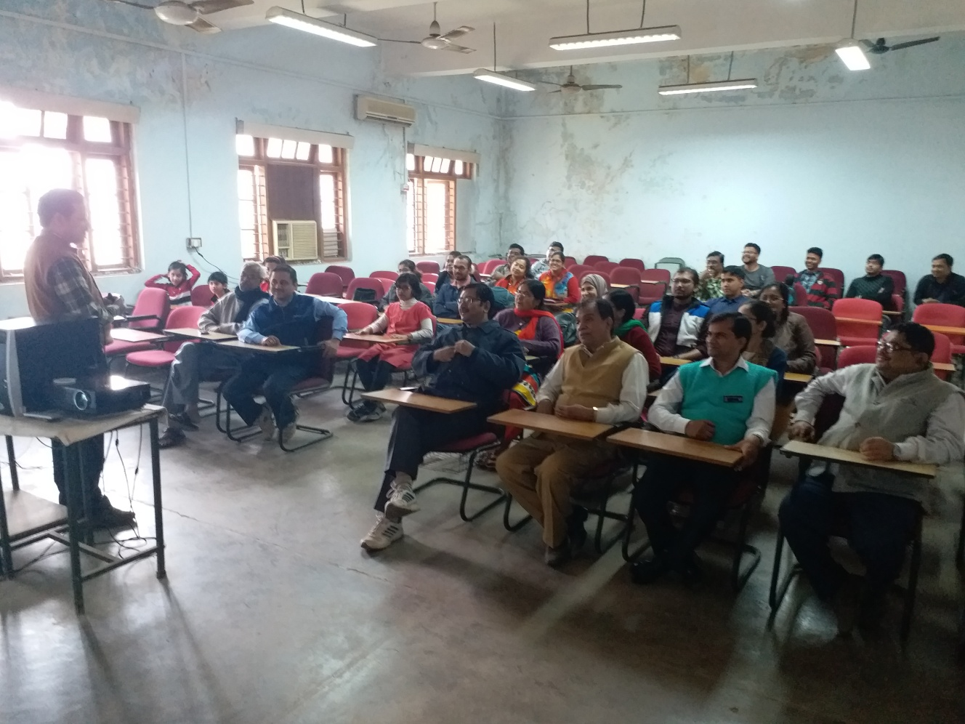

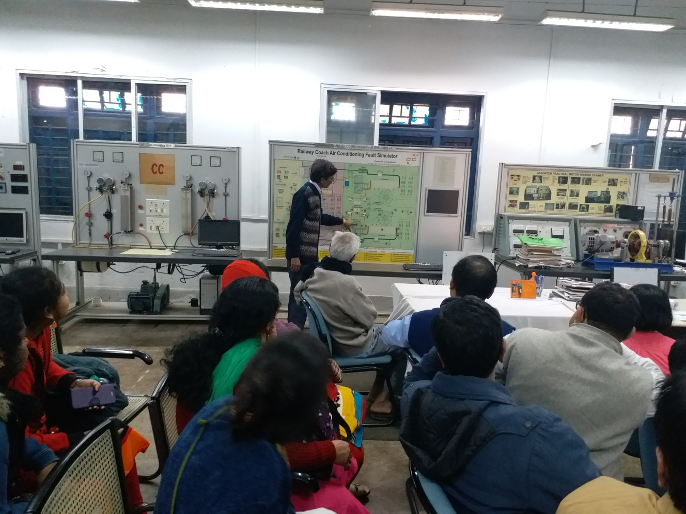

B.2 Chapter Activities

- Total number of Chapters in the Section: 3
- Number of Chapters formed in the current year: 0
- Number of active Chapters (Chapters who 1
have reported required number of meetings during the year)
- Summary of Chapter activities (Chapter wise with attachment table/information)
- CSS Chapter organized 1 technical talk
- EMB Chapter organized no technical talks
- SPS Chapter organized 7 technical talks
- AP/MTT student branch organized 4 technical talks

B.3 Professional and Continuing Education Activities
Summary of continuing Educational activities including conferences, technical activities, training courses, and distinguished lecture programs with attachment table / information
- Organized 11 technical talks
- Co-sponsored one technical conference

B.4 Students Activities

- Total number of Student Branches in the Section: 2
- Number of Student Branches formed in the current year: 0
- Section level student activities (student congress, paper and other contests, awards etc.):
- 1 boot camp
- 3 technical talks
- 6 Workshops
- Number of active Student Branches (Student Branches who have reported required number of meetings during the year) 1
- Summary of Student Branch activities (Student Branch wise with attachment table/information)
IIT Kharagpur SB
- 1 boot camp
- 3 technical talks
- 6 Workshops

B.5 Affinity Group Activities

- Young Professional (YP): Nil
- Women In Engineering (WIE):
- organized one startup event
- celebrated IEEE day
- Life Member: No activity

B.6 Awards & Recognition Activities

- Award constituted by the Section: Nil
- Please list all Awards and Recognitions received by the Section, and members in the Section, from R 10 and IEEE HQ during the year 2017: Nil

B.7 Communication Activities (Newsletter, Home Page, E-mail etc.)

- Newsletter (name and number of issues in the year): nil
- Home Page of the Section (give the URL and how often it is updated):Not Known
- Other means of contacts with Section members including social media:
- Regular e-mails were sent to all the section members informing them about seminar notices, conference announcements, India Council and R10 events and membership renewal dates.

B.8 Industry Relations

- Membership growth and retention : NIL
- Activities for/with industrial members: NIL

B.9 Humanitarian Technology Activities

- Humanitarian Technology related activities supported by the Section including collaboration with other OUs.: NIL
- SIGHT Activities: NIL

B.10 Community Activities:

- IEEE Social activities (Family day, IEEE day, Engineers Week)”
- IEEE day was celebrated

PART C - OTHERS

C.1 Special Events
NIL
C.2 Relationship with National and International Societies and Non-Government Organizations (NGO)
NIL
C3. Collaboration with other IEEE Sections
NIL
C.4 Support extended to Sub-sections & Society Chapters within the Section

- Support extended for organising technical, educational and professional activities
- A token financial support was given to Haldia subsection
- For all technical talks organized by chapters, section presented mementoes to speakers, publicized the activity and provided refreshments
- Joint activities for membership development: Nil
- Support extended for the formation of a Sub-section or transition of a Sub-section into a full Section: NIL

C.5 Best Practices of your Section (which you would like to share with other Sections for the benefits of members)
- Regularly high level technical talks are organized whenever some domain expert visits IIT Kharagpur
C.6 Problems anticipated and suggestions for solutions, if any
- Spare time with officers for section and chapter activities is decreasing fast. Need to motivate young volunteers capable of dedicated enough time for section level activities.

PART D - GOALS AND PLANS

D.1 Continuation of project/activity in progress and their implementation
plans
- To organize regular technical talks on emerging technologies
- To organize TechSym 2018 with the help of IIT Kharagpur student branch

D.2 Goals and Future Plans
- To obtain PAN for Kharagpur section and filing Income tax return.
- To start office activity from new office space at Nalanda Complex.
- To increase membership by reaching to new faculty members of IIT Kharagpur.
- To revive Haldia subsection activity.
- To revive the two underperforming societies viz. CSS and EMBS
- To form AP/MTT society with the help of AP/MMT student branch
- To revive WIE and YP affinity group activity.
- To start Humanitarian Activity of the section
- To start Community activity of the section by initiating a TISS (Teacher in Service Scheme) with IIT Kharagpur campus schools.
D.3 Any innovative ideas to make IEEE more creative and value added for sustaining the membership retention and recruitment goals.
Nil
D.4. Business Plan for Sustainable Growth and Financial Stability.
- To earn support from R10 by starting humanitarian activity projects
- To make use of continuing education program of the section to generate funds
- To integrate student branch finances with section so that funds generated from TechSym gets transferred to the section

