2017 IEEE Kansai Section Report

PART A - SECTION SUMMARY

A.1 Executive Summary

A.1-1 Section Executive Committee Member List (2017)
Section Officers:
Chair: Miki Yamamoto (Kansai University)
Vice-Chair: Takashi Mizuochi (Mitsubishi Electric Corporation)
Secretary: Yasutaka Takeda (Mitsubishi Electric Corporation)
Treasurer: Oka Seiji (Mitsubishi Electric Corporation)

Standing Committee Chairs:
Membership Development Committee Chair:
Masahiro Fukui (Ritsumeikan University)
Nominations Committee Chair:
Hisao Ishibuchi (Osaka Prefecture University)
Student Activities Committee Chair:
Arata Kawamura (Osaka University)
Technical Program Committee Chair:
Shinji Tanabe (Mitsubishi Electric Corporation)
Awards Committee Chair:
Tatsuhiro Tsuchiya (Osaka University)
Chapter Operations Committee Chair:
Yoshinobu Kajikawa (Kansai University)

Affinity Group Chairs:
Life Members Affinity Group Chair:
Masatsugu Kidode (ex Nara Institute of Science and Technology)
WIE (Women in Engineering) Affinity Group Chair:
Shoko Araki (Nippon Telegraph and Telephone Corporation)
YP (Young Professionals) Affinity Group Chair:
Takeshi Kumaki (Ritsumeikan University)

Past Officers/ Past Committee Chairs:
Past Chair: Hironori Yamauchi (Ritsumeikan University)
Past Vice-Chair: Mototaka Taneya (Sharp Corporation)
Past Secretary: Nobuyuki Takamori (Sharp Corporation)
Past Treasurer: Hiroshi Kawamura (Sharp Corporation)
Past NC Chair: Toshiharu Sugie (Kyoto University)

A.1-2 Section Highlights
The IEEE Kansai Section was established in November 1998. As of January, 2017, it comprises of 2,222 members (see B-1).
In 2017, we had five executive committee meetings, an annual section meeting and five technical meetings.
In 2017, we supported the HESTELCON 2017 in Kansai with great successes. We focused on connecting local electronics industries in Kansai area with students, researchers in universities/institutes and professionals and engineers in enterprises.
We endeavored to expand and enhance activities focusing on young people. Activities of LMAG, WIE, and YP are also activated. For example, two students were dispatched to ANZSCON 2017 held in Sydney in August. English presentation tournament was organized by SB, and brainstorming tournament was organized jointly by SB and LMAG. We also assisted participation in Nagoya MAW and worked with other sections.

A.1-3 Major Events (International, National)

A.1-3-1 Administrative Meetings
The Kansai Section had the following five executive committee meetings in 2017.

- 1st executive committee meeting Date: January 31th
Place: Kansai University Umeda Campus Attendance: 17
Issues: 2017 Actions and Financial Plans
Arrangements for 2017 Annual Meeting of Kansai Section
Annual Section Report Draft

- 2nd executive committee meeting Date: February 22nd
Place: MyDome Osaka Attendance: 15
Issue: Arrangements for 2017 Annual Meeting of Kansai Section

- 3rd executive committee meeting Date: June 5th
Place: Kansai University Umeda Campus Attendance: 14
Issues: Report on Region 10 annual meeting
Report on 1st Japan Council ExCom meeting
Young Professionals Award and Section Student Paper Award

- 4th executive committee meeting Date: September 11th
Place: Kansai University Umeda Campus Attendance: 11
Issues: Report on Japan Council ExCom meeting Report
Report on COC Meeting of Japan Council Report
Arrangements for the 100th Technical Lecture Meeting

- 5th executive committee meeting Date: December 21rd
Place: Kansai University Umeda Campus Attendance: 17
Issues: Young Professionals Award and Section Student Paper Award Selections
Report on 100th Technical Lecture Meeting Report
2017 Action report and settlement
2018 Actions and Financial Plans
Arrangements for 2018 Annual Meeting of Kansai Section

A.1-3-2 Annual Section Meeting
The Kansai Section had the Annual Section Meeting on February 22nd in 2017. The Committees, the Chapters, and the Affinity Group made presentations on their activities.
In the Kansai Section, 9 students were awarded the best paper awards, 2 Young Professional was awarded YP award. And 10 new senior members were awarded Kansai Section Medals.
Also, a new Fellow member had presentations about his researches.

A.1-4 Major Chapter Activities
- A total of more than 70 seminars and technical lecture meetings were held by each chapter, and more than 6,000 people participated in total (B.2).
- The representative events that received a lot of participation are as follows.
- On September 9, 2017, at Osaka Electro-Communication University AP-03 Kansai Joint Chapter organized “Antenna and Propagation Technology to Support the Next Generation Ultra High Speed Wireless Communication System”. The number of participants was 69 people.
- On June 19, 2017, at Ritsumeikan University, C-16 Kansai Chapter organized two lectures on the theme “AI to Cognitive Computing”. Prof. Taniguchi of Ritsumeikan University gave a lecture titled “The Road to Language Acquisition by Robots”, and Dr. Takagi of IBM Japan gave a lecture titled “Lifestyle where Cognitive Computing Changes”. At the lecture meeting, 92 active participants were gathered and an active question and answer session was held, and it was possible to have a place for valuable technical exchanges.
- On June 19, 2017, at Osaka University, PHO-36 Kansai Chapter organized special seminar. Three lectures were held, and 80 participants were attended the event.

A.1-5 Major Student and Affinity Group Activities
- On October 16, 2017, at Ritsumeikan University Biwako-Kusatsu Campus held the “English Presentation Competition” was held by the Student Branches
- The first MDC, SAC and YP joint workshop was held to discuss action plans on June 1, 2017.
- The second MDC, SAC and YP joint workshop was held to discuss promotion of IEEE on November 29, 2017.
- WIE Affinity Group held the 4th WIE symposium at Osaka Institute of Technology Umeda Campus on October 7, 2017, which garnered 42 participants (14 were non-IEEE members). The symposium consisted of three invited talks and one workshop session. This workshop was co-hosted by YP AG.
- Life Members Affinity Group (LMAG) held the following two technical meetings with on-site tours, (1) at Disaster Prevention Research Institute, Kyoto University in Uji-shi on June 6, 2017 with 14 participants (2) at the National Diet Library Kansai in Kyoto on November 22, 2017 with 14 participants.

A.1-6 Awards
- The Kansai Section Student Paper Awards were presented to 9 recipients in 2017.
- The Kansai Section Young Professional Award was presented to 2 recipient in 2017.
- The Kansai Section medals were presented to 10 newly elevated senior members in 2017.
A.2 Financial Report

The section’s finances are in good condition as shown below.

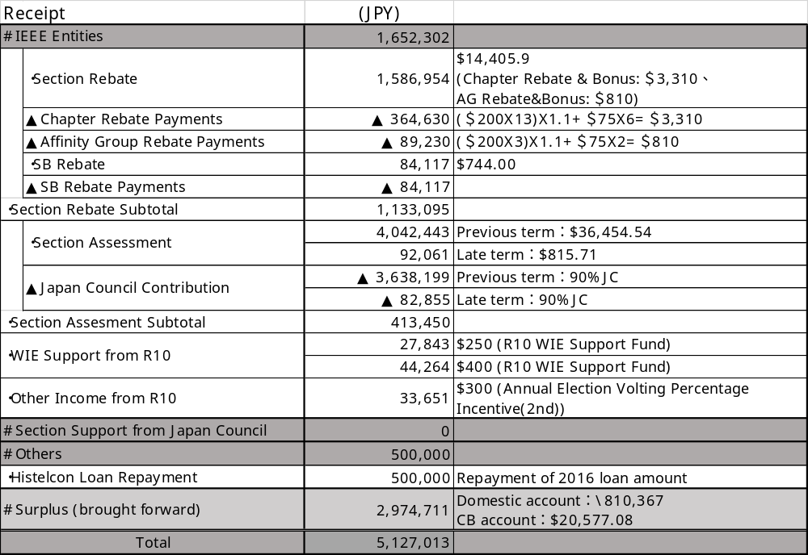

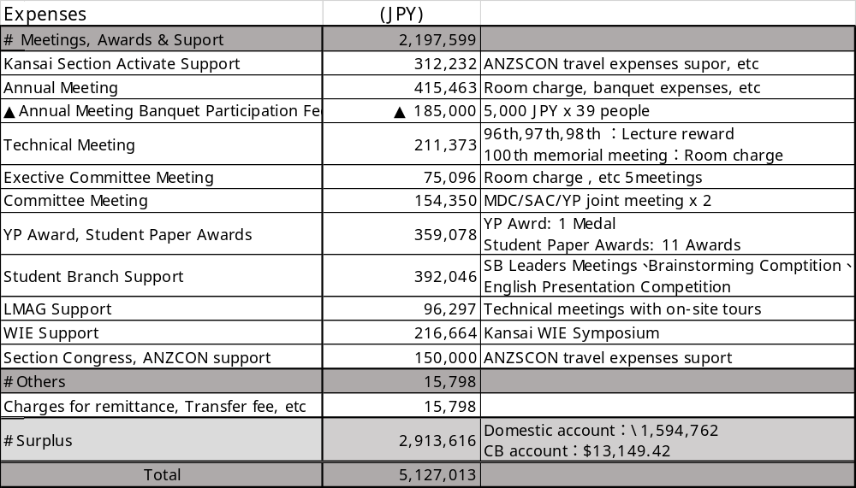

PART B - ORGANIZATIONAL ACTIVITIES

B.1 Membership Development Activities
The member statistics by grade in the section at the end of December, 2017 are as follows:

Grade | Grade Code | Number
Honorary Member | H | 1
Fellow | F | 73
Senior Member | SM | 151
Member | M | 1,602
Associate Member | AM | 62
Graduate Student Member | GSM | 285
Student Member | StM | 48
Total |  | 2,222

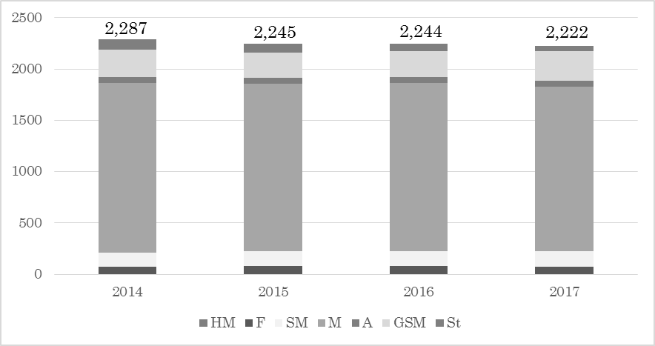

The Membership Development Committee has actively pursued the following projects to increase the number of IEEE members in the Kansai Section in corporation with Student Activities Committee.
- MDC organized two MDC, SAC and YP joint workshops on June 1, 2017 and November 29, 2017 to advertise and share the benefits of IEEE membership and to make a smooth transition for students from student membership to standard membership when graduated.
- MDC periodically reviewed the membership statistics in major organizations (companies and research institutes) and shared them with the MDC members who are from those organizations.
- MDC is continuously supporting the scheme to increase the number of Senior Members in the Kansai Section. Those IEEE members who wish to be a senior member can contact MDC and get quick and precise assistances. The application instructions for Senior Member grade on the section’s website were revised and became more informative, resulting in the number of newly elevated senior members in our section in a year became ten.
- To advertise IEEE membership, posters, leaflets and ball point pens with IEEE logos were presented at local technical meetings and workshops.
- Email to promote renewal was sent to all IEEE members in Kansai Section.
- The IEEE Kansai Section Medal is presented to new Senior Members. The medal is designed with a portrait of Gennai Hiraga, who was a multi-talented person, especially known as writer and inventor in Edo era, and assembled Japan’s first electrostatic generator (called Elekiter), which used the power of friction to generate electricity. We will present the medals to ten new Senior Members at the annual section meeting on February 28, 2018.

B.2 Chapter Activities
- Total number of Chapters in the Section is now 13 including 4 joint chapters.
- The number of Chapters has not increased this year.
- All 13 Chapters had activities in this year.
- Summary of Chapter activities (Chapter wise with attachment table/information)

Organizational Unit | Meeting Title | Meeting Date | Number of Attendees
SP01 | Conference on signal processing, engineering acoustics, and speech | 2017/3/1 | 109
SP01 | Seminar | 2017/3/29 | 29
SP01 | Seminar | 2017/4/24 | 18
SP01 | International Conference on Biometrics and Kansei Engineering | 2017/9/15 | 46
SP01 | Seminar by DL | 2017/9/22 | 20
SP01 | Seminar | 2017/11/22 | 15
AP03 | Special Talk | 2017/1/19
AP03 | IEEE AP-S Kansai Joint Chapter Best Presentation Award Ceremony | 2017/1/21
AP03 | Officers Meeting | 2017/1/21
AP03 | Special Talk | 2017/4/20
AP03 | Tutorial Workshop | 2017/9/9 | 69
AP03 | IEEE AP-S Kansai chapter and MTT-S Kansai Chapter Young Engineer Technical Meeting | 2017/12/9
CAS04 | 2017 Taiwan and Japan Conference on Circuits and Systems | 2017/8/21-23
CAS04 | Technical Lecture | 2017/11/24
CAS04 | Technical Lecture | 2017/12/1
CE08 | CE Society BoG Mtg. | 2017/1/8 | 10
CE08 | 2017 1st IEEE CE-08 West Japan Chapter 1st Officers' meeting | 2017/1/20 | 3
CE08 | 2017 1st IEEE CE-08 West Japan Chapter Research Meeting | 2017/1/20 | 16
CE08 | 6th IEEE Global Conference on Consumer Electronics | 2017/10/24 | 430
CE08 | 2017 1st IEEE CE-08 West Japan Chapter 2nd Officers' meeting | 2017/10/24 | 3
CE08 | 2017 1st IEEE CE-08 West Japan Chapter 3rd Officers' meeting | 2017/11/14 | 3
CE08 | 2017 TRON Symposium | 2017/12/13 | 350
IE13 | Joint Technical Meeting | 2017/1/27 | 123
IE13 | 217th Technical Meeting | 2017/4/22 | 84
IE13 | Distinguished Lecture | 2017/5/9 | 44
IE13 | 218th Technical Meeting | 2017/7/8 | 81
IE13 | 219th Technical Meeting | 2017/9/23 | 64
IE13 | 220th Technical Meeting | 2017/11/11 | 67
IE13 | Joint Technical Meeting | 2017/12/14 | 54
IE13 | 221st Technical Meeting | 2017/12/23 | 174
ED15 | 16th Kansai Colloquium, Electron Devices Workshop | 2017/1/30
ED15 | The 2017 International Meeting for Future of Electron Devices, Kansai | 2017/6/29
ED15 | Technical Lecture meeting | 2017/10/3
C16 | AI to Cognitive Computing | 2017/6/19 | 92
C16 | The latest technology surrounding a Spacecraft | 2017/12/21 | 24
MTT17 | Workshops on R&D and international standardization on wireless technologies for railway systems | 2017/1/21 | 57
MTT17 | Workshops on substrate and material technology for high speed high frequency signals | 2017/4/22 | 69
MTT17 | The 10th Kansai Microwave Meeting for Young Engineers | 2017/7/1 | 59
MTT17 | Kansai chapter 10th anniversary Workshops on Future of Energy with Microwave Technology | 2017/9/2 | 89
MTT17 | Workshops on micro wave and millimeter wave photonics | 2017/11/19 | 33
MTT17 | IEEE AP-S Kansai chapter and MTT-S Kansai Chapter Young Engineer Technical Meeting | 2017/12/9 | 81
COM19 | Distinguished Lecture | 2017/6/30 | 11
COM19 | Distinguished Lecture | 2017/7/28 | 12
COM19 | Distinguished Lecture | 2017/8/3 | 11
COM19 | Student Workshop | 2017/10/26 | 15
CS23 | SICE Kansai - ISCIE workshop for young researchers | 2017/1/13 | 104
CS23 | SICE Multi Symposium on Control Systems 2017 (MSCS2017) | 2017/5/6 | 510
CS23 | Seminar | 2017/5/17 | 30
CS23 | Seminar | 2017/6/7 | 16
CS23 | ISCIE - SICE tutorial lecture | 2017/7/14 | 39
CS23 | The 49th Stochastic Systems Symposium | 2017/11/3 | 70
CS23 | ISCIE seminar | 2017/11/9 | 26
CS23 | The 60th Joint Conference on Automatic Control | 2017/11/10 | 670
MAG33 | The 3rd Kansai Shikoku Magnetics Symposium | 2017/6/24 | 30
MAG33 | Distinguished Lecture | 2017/8/3 | 50
MAG33 | Distinguished Lecture | 2017/9/25 | 31
PHO36 | IEEE Photonics Society Kansai Chapter Special Seminar | 2017/1/18 | 70
PHO36 | IEEE Photonics Society Kansai Chapter Special Seminar | 2017/9/29 | 80
PHO36 | PS Kansai Chapter 3rd Presentation School for International Conferences on Photonics | 2017/9/30 | 29
PHO36 | Pre-Conference of ISLC2018 | 2017/12/15 | 100
SSC37 | IEEE SSCS Kansai Chapter Technical Seminar | 2017/12/29 | 8
SSC37 | IEEE SSCS Kansai Chapter Technical Seminar | 2017/12/4 | 15
SSC37 | IEEE SSCS Kansai Chapter Technical Seminar | 2017/10/6 | 25
SSC37 | The 7th International Conference on Integrated Circuits, Design, and Verification | 2017/10/5 | 62
SSC37 | VDEC D2T Symposium | 2017/9/28 | 181
SSC37 | Integrated Circuits and Systems Seminar | 2017/9/7 | 58
SSC37 | VDEC Designer's Forum 2017 | 2017/9/4 | 34
SSC37 | Integrated Circuits and Systems Seminar | 2017/8/28 | 16
SSC37 | VLSI Summer School | 2017/8/25 | 111
SSC37 | Integrated Circuits and Devices Seminar | 2017/7/31 | 126
SSC37 | IEEE SSCS Japan/Kansai Chapter Technical Seminar | 2017/6/15 | 67
SSC37 | IEEE SSCS Japan/Kansai Chapter Technical Seminar | 2017/6/15 | 67
SSC37 | VDEC Refresh Seminar | 2017/6/12 | 84
SSC37 | JSPS 165th Committee on Ultra Integrated Silicon Systems, Friday Forum | 2017/6/9 | 248
SSC37 | LSI and Systems Workshop | 2017/5/15 | 347
SSC37 | Integrated Circuits and Systems Seminar | 2017/4/10 | 64
SSC37 | International Nano Device Technology Workshop 2017 | 2017/3/2 | 100
SSC37 | Integrated Circuits and Devices Seminar | 2017/3/2 | 81
SSC37 | IEEE SSCS Kansai Chapter Technical Seminar | 2017/2/17 | 41
SSC37 | Integrated Circuits and Devices Seminar | 2017/1/30 | 49
B.3 Professional and Continuing Education Activities

The section organized the following five technical meetings.

1.
Lecturers: Prof. Hiromi Tanaka (Ritsumeikan University)
Titles: Visio-Haptic Information Processing of Deformable Objects and Applications
Date: April 28, 2017
Place: Ritsumeikan University, Umeda Campus (Osaka City, Osaka, Japan)

2.
Lecturer: Prof. Mitsunori Hatayama
(Disaster Prevention Research Institute, Kyoto University)
Titles: Utilization of ICT/RT for disaster response
Date: June 22, 2017
Place: Disaster Prevention Research Institute, Kyoto University
(Uji City, Kyoto, Japan)

3.
Lecturers: Prof. Masahiro Yamaguchi (School of Engineering, Tohoku University)
Titles: High Frequency Magnetic Device Progress and Application to IC-Chip-Level Noise Reduction
Date: September 5, 2017
Place: Ritsumeikan University, Umeda Campus (Osaka City, Osaka, Japan)

4.
Lecturer: Ms. Nobuaki Honda (National Diet Library Kansai)
Title: Efforts towards long-term preservation of electronic information at the National Diet Library
Date: November 22, 2017
Place: National Diet Library Kansai (Seika-machi Sagara-gun , Kyoto, Japan)

5.
Lecturers: Emeritus Prof. Makoto Nagao (Kyoto University)
Titles: History of Artificial Intelligence and My Research
Date: December 16, 2017
Place: Kansai University Umeda Campus (Osaka City, Osaka, Japan)

B.4 Students Activities
- The Kansai Section has seven student branches: Osaka University, Kyoto University, Ritsumeikan University, NAIST (Nara Institute of Science and Technology), University of Hyogo, Kansai University, and Doshisha University.
- The Kansai Section tried to form a new student branch, but we could not form new student branches.
- Those seven student branches are all active.
- The chairs of the student branches held SB Chair Meeting on May 26, 2017, where they reported their activities and discuss action plans.
- The Student Activities Committee (SAC) organized two MDC, SAC and YP joint workshop on June 1, 2017 and November 29, 2017 to support young and women members.
- The SAC founded the Kansai Section Student Paper Awards to encourage student members of the Kansai Section in their research activities of presenting excellent papers at IEEE international conferences and in IEEE Transactions. In cooperation with the Awards Committee, we selected nine award recipients in 2017.
- The Student Branch of Ritsumeikan University held its annual English Presentation Competition at Biwako-Kusatsu Campus on October 20, 2017.
- As a networking activity, Kansai Section Student Branches exchange meeting was held on July 9, 2017 at Kyoto University.
- At the 100th Technical Lecture, each SB reported its activity status and tried to widely publicize.
B.5 Affinity Group Activities

B.5-1 Young Professional Affinity Group
- SYWL joint workshop＠IEEE Japan Sections' 60th Anniversary Celebration (March 3, 2017 at Chiba Institute of Technology) .
- The first MDC, SAC and YP joint workshop was held to discuss action plans on June 1, 2017.
- The second YP meeting was held to check and discuss action plans on November 29, 2017.
- Japan SYWL Workshop in Nagoya 2017 (October 8, 2017 at Chukyo University Nagoya Campus).
- YP co-hosted the 4th WIE Symposium on October 7, 2017.
- YP essay contest (result announced on November 9, 2017).

B.5-2 WIE Affinity Group
- WIE Affinity Group held the 4th WIE symposium at Osaka Institute of Technology Umeda Campus on October 7, 2017 with 42 participants. The symposium consisted of three invited talks. This workshop was co-hosted by YP AG.
- On June 6, 2017, WIE joined Women in Circuits Networking Luncheon （IEEE SSCS Organized by Women in Circuits (WiC) 2018 Symposia on VLSI Technology and Circuits) .
- On October 8, 2017, Poster presentation at 10/8 Metro Area Workshop (MAW) in Nagoya 2017
- WIE joined in the IEEE Japan SYWL Workshop Nagoya 2017.
- WIE co-sponsored the 9th Career Development Essay Contest for Young Professionals and Women Engineers.
- WIE had five officers meetings in 2017 for discussing our action plans and for preparing the WIE symposium.

B.5-3 Life Members Affinity Group
- LMAG had 6 officers meetings in 2017 to discuss action plans.
- In corporation with TPC, LMAG held the following two technical meetings with on-site tours, namely, (1) at Disaster Prevention Research Institute, Kyoto University, Kyoto Prefecture on June 22, 2017 with 15 participants and (2) at National Diet Library Kansai, Kyoto Prefecture on November 22, 2017 with 13 participants.
- LMAG issued "Kansai-LMAG Newsletter" in June and November by email and on the Kansai Section WEB. Through these activities, LMAG has developed up-to-date LMAG members' network. The new officers in 2017 were announced in September issue.
- The new activity plan called “LMAG Salon” was realized. More frequent and frank discussion is expected.
- In September, LMAG participated in a brainstorming lecture and practical event sponsored by SB as the first attempt, and cooperated as a lecturer

B.6 Awards & Recognition Activities
- The Kansai Section Student Paper Awards were presented to 9 recipients in 2017.
- The Kansai Section Young Professional Award was presented to 2 recipient in 2017.
- The Kansai Section medals were presented to 10 newly elevated senior members in 2017.

B.7 Communication Activities (Newsletter, Home Page, E-mail etc.)
- We updated the Kansai Section Home Page more than once a month. They announced section annual meeting and Young Professionals and student awards announcements and results and new officers and new executive committee member candidates as well as summaries and announcements of the past and upcoming technical meetings.
http://www.ieee-jp.org/section/kansai/
- We also actively used Mailing List for timely announcements of upcoming events.

B.8 Industry Relations
- 22 members decreased.
- MDC is continuously supporting the scheme to increase the number of Senior Members in the Kansai Section. Those IEEE members who wish to be a senior member can contact MDC and get quick and precise assistances. The application instructions for Senior Member grade on the section’s website were revised and became more informative, resulting in the number of newly elevated senior members in our section in a year became ten.
- WIE Affinity Group held the WIE Symposium, to support women engineers in the Kansai area.
- In 2017, one young researcher in industry was awarded Young Professional Award.

B.9 Humanitarian Technology Activities

B.10 Community Activities

PART C - OTHERS

C.1 Special Events

C.2 Relationship with National and International Societies and Non-Government Organizations (NGO)
- Kansai-section Joint Convention of Institutes of Electrical Engineering
Organizer(s): The Institute of Electrical Engineers of Japan,
The Institute of Electronics, Information and Communication Engineers,
The Institute of Image Information and Television Engineers,
The Institute of Electrical Installation Engineers of Japan
Dates: November 25-26, 2017
Place: Kindai University Higashi-Osaka Campus

- The 4th Electronic Device Forum Kyoto
Organizer(s): Nippon Electronic Device Industry Association (NEDIA)
Dates: November 1-2, 2017
Place: Kyoto Industrial Science and Technology Innovation Center, Kyoto Research Park

- 2017 Annual Conference of Electronics, Information and Systems Society, I.E.E. of Japan
Organizer(s): The Institute of Systems, Control and Information Engineers
Dates: November 9, 2017
Place: Kyoto Terrsa East-D

C3. Collaboration with other IEEE Sections
- Ten members joined Nagoya MAW held on October 7-8, 2017 and collaborated with members of the Nagoya Section. Kansai LMAG members supported the establishment of Nagoya LMAG, which started on the same day as Nagoya MAW.
- Two Student Branch members participated in ANZSCON 2017 held on August 10-11. This Congress has a lot of opportunities to interact with students and YPs from various countries, and they have been useful experience for revitalizing future SB activities.
- WIE Symposium held on October 7, 2017 was collaborated with WIE of Japan Council. MD Chair of Japan Council was attended.

C.4 Support extended to Sub-sections & Society Chapters within the Section

C.5 Best Practices of your Section (which you would like to share with other Sections for the benefits of members)

C.6 Problems anticipated and suggestions for solutions, if any
PART D - GOALS AND PLANS

D.1 Continuation of project/activity in progress and their implementation
plans

D-1-1 Executive Meetings
We will have five executive committee meetings this year. We already had one executive committee meetings in January.

D-1-2 Membership Development Committee
The members in MDC will try to increase memberships in their respective organizations.

D-1-3 Nominations Committee
The NC will nominate Fellow upgrade candidates.

D-1-4 Student Activities Committee
The SAC will try to open new student branches in the Kansai Section. The SAC is also planning some technical and social events for students in the Kansai Section.

D-1-5 Awards Committee
The AC will conduct the selection process for the IEEE Kansai Section Young Professionals Awards and IEEE Kansai Section Student Paper Awards.

D-1-6 Chapter Operations Committee
The COC will promote cooperation between chapters and will work to establish new chapters and extend existing chapters into joint chapters in the Kansai Section.

D-1-7 Technical Program Committee
The TPC will plan and hold five technical meetings.

D-1-8 Affinity Groups
- Life Members Affinity Group
LMAG holds several lecture meetings (including local lectures) in cooperation with TPC, WIE, etc. of the Kansai branch. Actively cooperate with YP, SB and WIE with M3G (Multi-Generation, Gender and Genre) as the guiding principle. We will issue “Kansai-LMAG Newsletter” by email and on the Kansai Section WEB.

- WIE Affinity Group
In 2018, WIE AG celebrates its 5th anniversary.
· Recruit members who agree with WIE activities, and strengthen the management system.
· To hold symposiums to support women researchers and engineers.
· Promote WIE activities in Kansai, in collaboration with Student Branch, YP, LMAG, JC WIE, other activities related to women's support of academic societies and others.

- YP Affinity Group
The YP AG will plan events and meetings aiming at encouraging young researchers and engineers to communicate and exchange useful information in corporation with Kansai TPC and Kansai LMAG/WIE.

D-1-9 Chapters
Each chapter will hold various events including technical meetings, workshops and conferences.

D.2 Goals and Future Plans

D.3 Any innovative ideas to make IEEE more creative and value added for sustaining the membership retention and recruitment goals.

D.4. Business Plan for Sustainable Growth and Financial Stability.

Photographs
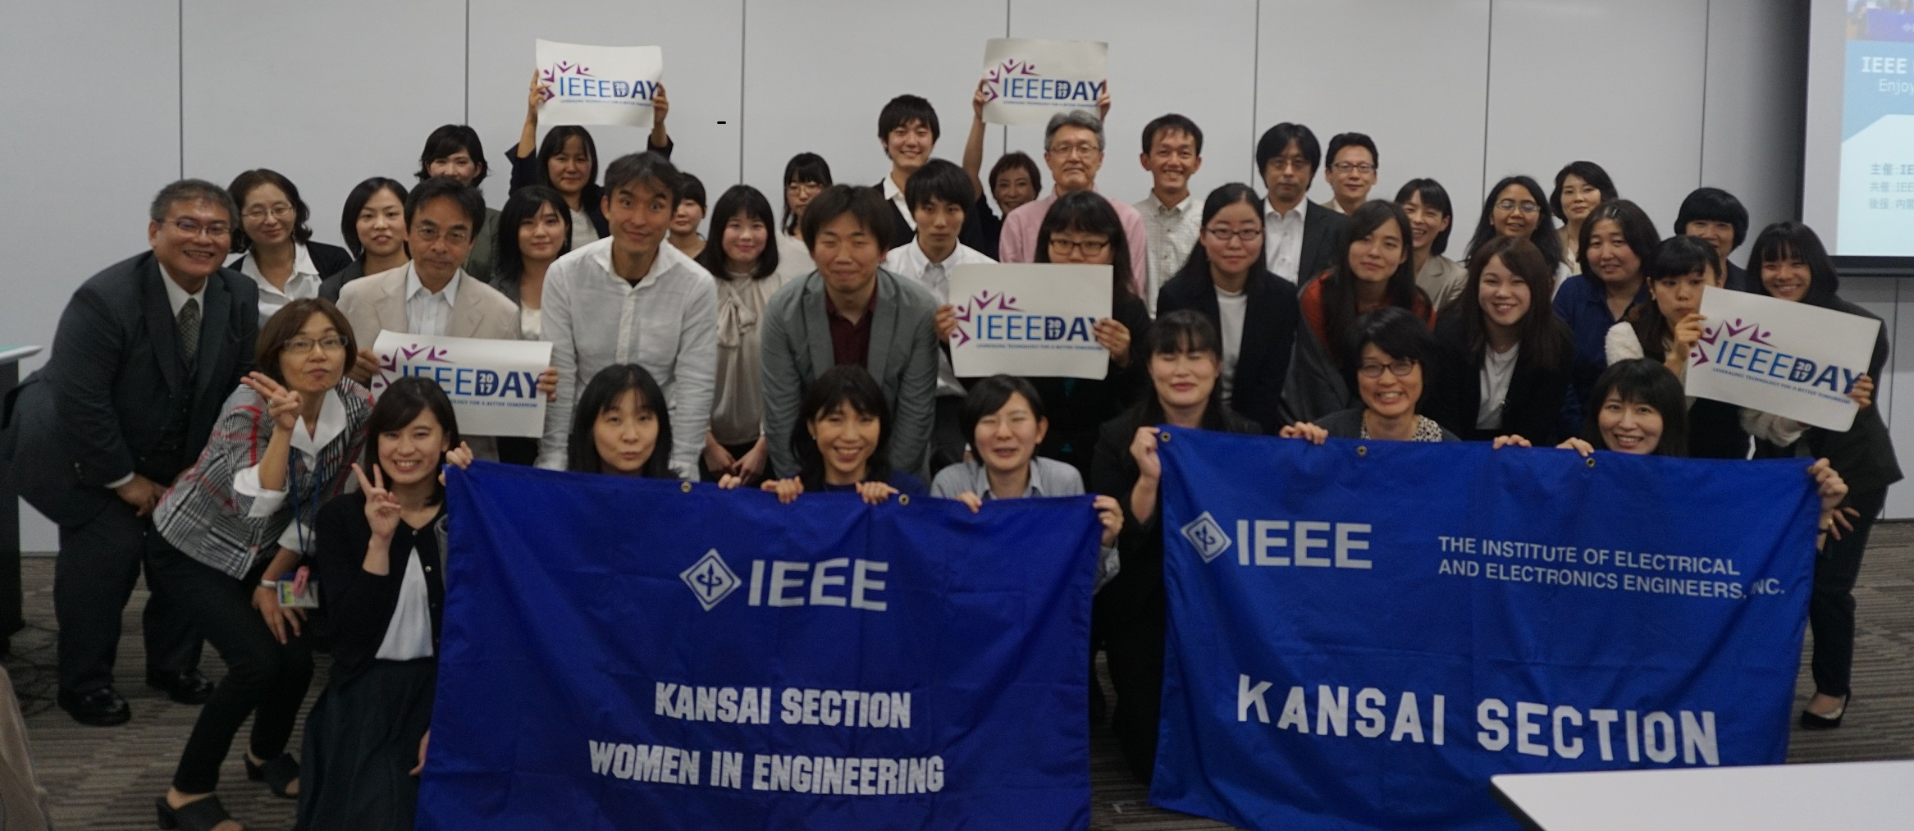
WIE Symposium

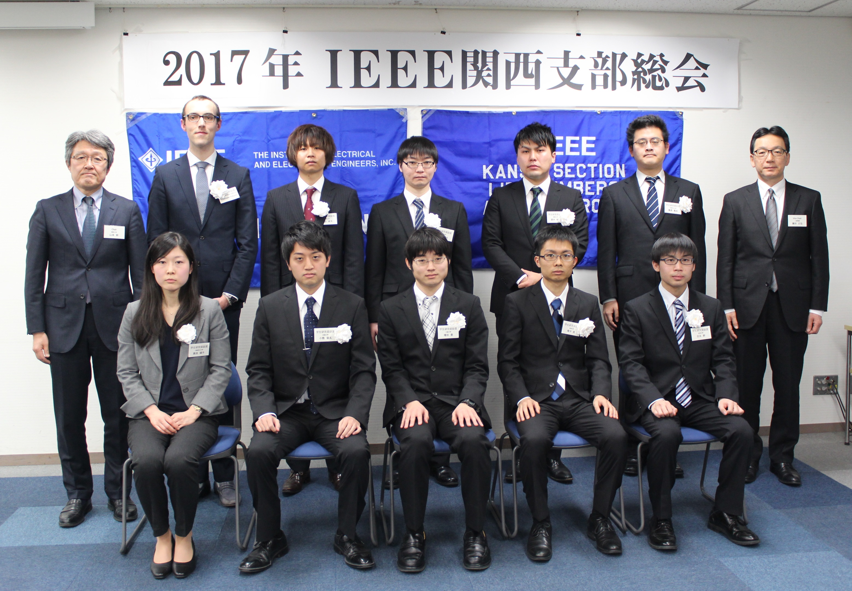
Student Paper Awards

